Questionnaire
Multi Phase Extraction
IMPEL Project no. 2020/09

Delivering time 5th October 2021 – 15th December 2021

TABLE OF CONTENTS

Context 3
Introduction 5
1. Your contact details 9
2. Site background 10
3. Pilot-scale application in field 14
4. Full-scale application 20
5. Results 26
6. Post treatment and/or Long Term Monitoring 27
7. Additional information 28
Glossary of Terms 32

Context

The contaminated sites management is a process that has different speeds in Members States. This is due partly on difference in legislation that would mean different definitions as for making some examples “potentially contaminated sites”, “contaminated sites”, “remediated sites”. For this reason, the European Commission-JRC launched an initiative with EEA-EIONET network to find common definitions and a survey in MS in 2018 (https://ec.europa.eu/jrc/en/publication/status-local-soil-contamination-europe-revision-indicator-progress-management-contaminated-sites) that resulted in defining 6 site statuses.

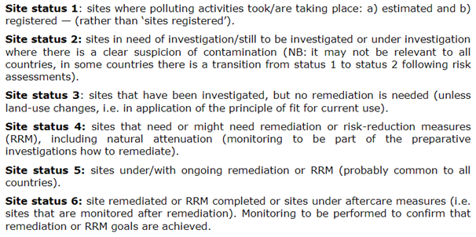

The last definition Site Status 6 refers to remediation that independently which are the targets (reaching a concentration limit set by law, reaching an acceptable risk for human health, reaching an acceptable environmental risk or other) is more or less common to all. The fact is that the progress in management go slowly in particular for the last phase with some of the countries with substantial no progress, the report says.
This project aim to speed up the process, focusing to the remediation phase that is often the bottleneck, with Remediation Verification Scheme.

The desired outcomes are:
• Support/exchange technical experience required to make progress with the task “Remediation verification scheme” in Europe in order to enable those MS in which no procedure is currently taking place to have one reference
• Schemes for remediation verification

Introduction

This questionnaire looks at the input of case studies where Soil Vapor Extraction were applied in a contaminated site. The questionnaire is divided in four steps:

1) The pilot study
2) The treatment
3) The enhancement applied
4) The post remediation scheme

The questionnaire will remain active in the period comprehended between 5th October to 15th December 2021 for the collection of case study. Late submission could be evaluated by the project team.

Each case study may have details of the site location, details of the author(s) and their affiliation and companies involved. Those information would help in understanding more about the site but are not mandatory.
At least one contact point is mandatory, for resolving any potential problem related to the publication.

It is allowed to make reference to registered products and/or patent but it is necessary to make reference to active species present and eventually by-products or side effects (e.g. pH increase).

The purpose of this project is to analyse a collection of case studies in order to identify criteria to effectively and promptly assess the correct evaluation of each step of the remediation activity. In particular, the criteria for evaluating and monitoring the performance of each step will be defined through the determination of some clues and evidences. Consequently, the intended outcome of the project is also to create a “Remediation Verification Scheme” that may be used as tools for practitioners. This tool could not necessarily be applied in all the situations but it will be an important reference to understand if the remediation technology is performing as planned.

Please note: data on the costs, on environmental net benefit as well as the sustainability aspects are not included in the objective of this study.

The purpose of this Questionnaire is to collect specific information on cases of remediation technology. To do so, you are kindly requested to submit one or more case studies each with a different file.
In case you cannot fill the questionnaire please answer to the last question in order address the project team your possible remarks, concerns, requests, suggestions.

As previously mentioned, the responses of the filled Questionnaires will be analysed in order to identify criteria for the evaluation of the performance of the remediation. The experiences collected may be useful to prepare the monitoring plan of different remediation phases for similar cases.

You can both fill the Questionnaire in Annex I and upload documents in English.

Please copy-paste, in the Questionnaire answers, any images, photos, maps, graphs, flowcharts and diagrams that can be useful for a better understanding.
Please send the Questionnaire to marco.falconi@impel.eu.
In case the file of the filled Questionnaire and/or of any useful document attached is too large, please send it/them to via We Transfer (https://wetransfer.com/) or Share File (https://www.sharefile.com/) or any other preferred internet tool.

Final note: The Questionnaire should not be completed only with successful cases of remediation technology application but also with unsuccessful assessment cases; in fact, for those unsuccessful cases, shortcomings and improvement actions will be identified and analysed.
Moreover, feel free to share this questionnaire to inspectors, a public officers or any other stakeholders. Participation or consultancy, site owners, environmental service companies are welcomed.

Thank you very much for your collaboration from all the WLR project team.

If you need assistance or clarifications, you may contact:
Mr. Marco Falconi
Email: marco.falconi@impel.eu
Mobile Phone: +39 3471204170

DISCLAIMER:
The questionnaire is subject to the Directive 2003/4/EC of the European Parliament and of the Council of 28 January 2003 on public access to environmental information.
As a consequence, the information contained in the filled Questionnaire will not be confidential, not only for the information of the intended recipient and may be used, published or redistributed by IMPEL without the prior written consent of the compiler.

Annex 1
Multi Phase Extraction
IMPEL Project no. 2020/09

Delivering time 5th October 2021 – 15th December 2021

- Your contact details

  - Name and Surname*
  - Country/Jurisdiction
  - Organisation
  - Position
  - Duties
  - Email address
  - Phone number
* If you do need, you can fill the Questionnaire as anonymous. In this case, we kindly ask you to fill just the box no. 1.6, 1.7, that will be used to contact you for any problems related to the publication.

- Site background
2.1 History of the site
Please describe the history of the site (you may add one or more pictures)
- (your answer) …

- EXAMPLE OF ANSWER

Basket Creek was used in the 1960s for illegal disposal of liquid refinery and other hazardous wastes. In 1991, soil at the site was identified as a RCRA hazardous waste exhibiting the Toxicity Characteristic (TC) for lead, MEK, and TCE.

2.2 Geological setting
Please describe the geological setting (you may add one or more pictures)
- (your answer) …

- EXAMPLE OF ANSWER

Site soil consists largely of fine sands with some silts, interbedded with veneer-thin stringers of sand and thicker layers of nearly saturated silts and clays. The depth to ground water is approximately 10 meters below ground surface.

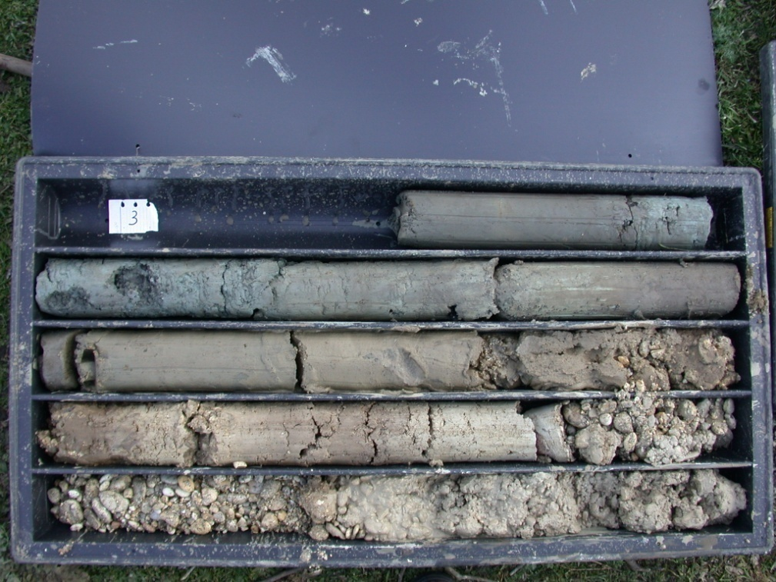

2.3 Contaminants of concern
Please describe the contaminants of concern
- (your answer) …

- EXAMPLE OF ANSWER

Organic Compounds (Volatiles - Halogenated: trichloroethene (TCE); and Volatiles - Nonhalogenated: toluene, methyl isobutyl ketone (MIBK), and methyl ethyl ketone (MEK)) and Inorganic Compounds, (Heavy Metals: lead and mercury)
- Toluene: BDL-220,000 mg/kg
- MIBK: BDL-66,000 mg/kg
- MEK: BDL-23,000 mg/kg

2.4 Regulatory framework
Please describe the regulatory framework applicable
- (your answer) …

- EXAMPLE OF ANSWER

EPA signed an Action Memorandum for Basket Creek. Initial activities included sampling to characterize the nature and extent of contamination at the site. Tue soil was found to be a RCRA hazardous waste by exhibiting the Toxicity Characteristic (TC) for lead, methyl ethyl ketone, and ·trichloroethene.
Additionally, the soil was found to be a California List Waste under the RCRA Land Disposal Restrictions program because total halogenated organic compounds were greater than 1,000 parts per million (ppm) and, therefore, waste from the site was prohibited from land disposal. As described under the Contamination Characterization section of this report, elevated levels of mercury were also found in the soil; however, the soil was not identified as exhibiting the TC for mercury.
The action memorandum identified treatment targets for soil, including TC regulatory levels for selected volatile organic compounds (VOCs) and metals, and the California List regulatory level of 1,000 ppm for total HOCs.

- Pilot-scale application in field
3.1 Extraction system
Please describe the number and characteristic of extraction system in the pilot scale application in field
- Single Pump configuration (extract air and liquid)
- Dual Pump configuration (submersible pump for groundwater recovery in conjunction with a separate vacuum applied at the sealed wellhead)
- Bioslurping (extraction at the interface air liquid)
- Other
  - High-Vacuum Dual Phase Extraction (HVDPE)
  - Low-Vacuum Dual Phase Extraction (LVDPE)
  - …….

- (your answer) …

- EXAMPLE OF ANSWER

The two-pump MPE system utilizes a submersible pump for groundwater recovery in conjunction with a separate vacuum applied at the sealed wellhead. In this configuration, liquid and vapor streams are separate from one another. Conductivity type level sensors can be utilized for pump control. Level control may be necessary to prevent the vacuum from causing the pump to lose positive suction head and cavitate. Depending on the application, two-pump systems can utilize electric or pneumatic submersible pumps for groundwater recovery and liquid ring pumps or blowers to induce vacuum. Applications for the recovery of a free product, or light, non-aqueous phase liquid (LNAPL), typically employ pneumatic submersible pumps for liquid recovery

3.2 Feasibility study
Please describe the number and characteristic of parameters used for evaluating MPE as a feasible alternative
- Mass removal
- Air extraction rates
- DNAPL/LNAPL recovery
- (your answer) …

- EXAMPLE OF ANSWER

Aquifer tests and a DPE pilot test were conducted to gather site-specific data including transmissivity, specific yield, groundwater recovery rates, hydrostatic responses, vadose zone vacuum distributions, intrinsic permeability, air extraction rates, and SVE mass removal rates. Overall the test supported the
use of DPE for VOC recovery. The test data supported the design of a larger DPE system.
The pilot test also showed the need to employ air injection to facilitate vadose zone air flow.
Several performance goals were established for remediation of groundwater by DPE at the site. The first goal was to remove contaminated groundwater from the upper aquifer for ex-situ treatment by air stripping. In addition, DPE was to lower the groundwater table to increase the volume of semi-saturated soil through which air flow and volatilization of constituents would occur. Based on theory and practice, mass transfer of VOCs from the soil will continue to occur, provided drawdown is maintained. Moreover, DPE was sought to maintain a constant hydraulic gradient toward the DPE wells to prevent off-site migration.
The performance goals for DPE were set to evaluate its effectiveness in achieving remedial action objectives (RAOs) for the site. The RAOs are as follows:
• Reduction of the highest levels of contamination resulting in immediate risk reduction;
• Plume containment of contamination in excess of remedial goals;
• Achievement of remedial goals (PCE 5 )g/L, TCE 5 )g/L), or attainment of an asymptotic trend in contaminant of concern (COC) concentrations in groundwater (whichever occurs first).

3.3 Radius of influence
Please describe how do you calculate the radius of inflence by pilot test data for extraction and injection wells, in the pilot scale application in field. Examples of parameters that are helpful to calculate the radius of influence
- Water drawdown versus distance
- Wellhead vacuum
- Vapor extraction rates

- (your answer) …

- EXAMPLE OF ANSWER
Radius of influence (ROI) was calculated around 8 meters on the basis of induced vacuum. A drowdown of 0,3 ft of waterwas considered as the boundary of the effect of the well.
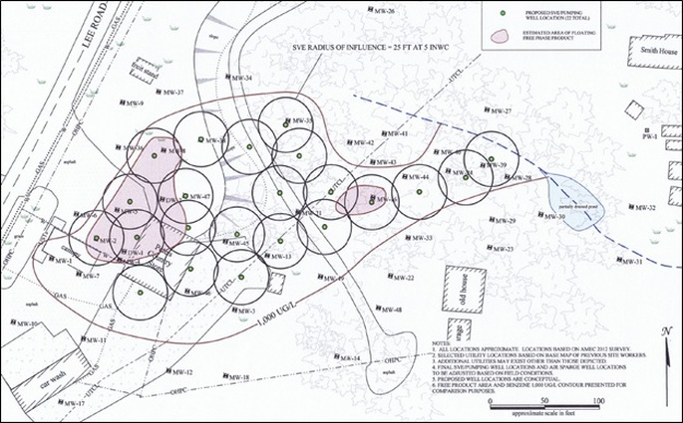

3.4 Off gas Treatment
Please describe if and which treatment was installed for off gas, in the pilot scale application in field
- Thermal Oxidation
- Internal Combustion Engines
- Activated Carbon Adsorption
- Zeolite Adsorption
- Synthetic Polymer Adsorption
- Biofiltration
- Membrane Separation
- Other technologies
- (your answer) …

- EXAMPLE OF ANSWER
A baghouse was used to remove all particulates from the air stream.
The baghouse consisted of a metal structure housing 96 filter bags designed to remove particles down to 0.5 microns. The system used 24-inch flexible duct work to route the vapors from the interior of the building to•the exterior. Galvanized steel ducts were used to route the air through the baghouse and into the thermal oxidizer.
The thermal oxidizer was a three chamber, propane fired unit designed to treat 10,000 cfm of vapors with greater than 99% destruction and removal efficiency. Five 1,000-gallon propane tanks were staged on site to supply fuel for the unit.

3.5 Water Treatment
Please describe if and which water treatment was installed in the pilot scale application in field
- Granulated Activated Carbon
- Stored and disposed off site
- Sent to a Wastewater Treatment Plant
- Dumped in sewerage
- Nothing
- (your answer) …

- EXAMPLE OF ANSWER
The effluent goes to an existing groundwater treatment plant.

3.6 Control parameters
Please make a list of control parameters for the pilot scale application in field that are helpful for the feasibility full scale.
Field monitoring and sampling program that will adequately monitor the effectiveness of the treatment in three dimensions.
- (your answer) …

- EXAMPLE OF ANSWER
To assess the progress of the remediation, soil vapor samples were collected from six SEAMIST wells. The six SEAMIST wells were located throughout the soil vapor extraction wellfield. Five SEAMIST wells contained 10 sample ports each, and one well contained 9 ports. The sample ports in each SEAMIST well were vertically distributed in the primary stratigraphic units determined from site investigation borings and well logs. The SEAMIST well vapor samples were collected 1-liter Summa™ canisters and analyzed for TCE, PCE, and 1,2-DCE using a modified EPA Method TO-14.

- Full-scale application
4.1 Full design system
Please describe
- the number and characteristic of extraction system in the full scale application
- Single Pump configuration (extract air and liquid)
- Dual Pump configuration (submersible pump for groundwater recovery in conjunction with a separate vacuum applied at the sealed wellhead)
- Bioslurping (extraction at the interface air liquid)
- Other
  - High-Vacuum Dual Phase Extraction (HVDPE)
  - Low-Vacuum Dual Phase Extraction (LVDPE)
  - …….
- Piping and above ground equipment
- Instrumentation and process control
- (your answer) …

- EXAMPLE OF ANSWER

The two-pump MPE system utilizes a submersible pump for groundwater recovery in conjunction with a separate vacuum applied at the sealed wellhead. In this configuration, liquid and vapor streams are separate from one another. Conductivity type level sensors can be utilized for pump control. Level control may be necessary to prevent the vacuum from causing the pump to lose positive suction head and cavitate. Depending on the application, two-pump systems can utilize electric or pneumatic submersible pumps for groundwater recovery and liquid ring pumps or blowers to induce vacuum. Applications for the recovery of a free product, or light, non-aqueous phase liquid (LNAPL), typically employ pneumatic submersible pumps for liquid recovery.

4.2 Different areas characteristics that affect the project
Please describe the specific characteristics that caused different application of MPE in the affected areas
- Areas with bigger permeability
- Areas with two aquifers interconnected
- Different groundwater direction (for tide or other)
- Etc.

- EXAMPLE OF ANSWER

The east area has groundwater level much depper than other parts. This resulted in higher drowdown.

4.3 Radius of influence
Please describe how did you calculate the final radius of inflence. Examples of parameters that are helpful to calculate the radius of influence
- Water drawdown versus distance
- Wellhead vacuum
- Vapor extraction rates

- (your answer) …

- EXAMPLE OF ANSWER
Radius of influence (ROI) was calculated around 8 meters on the basis of induced vacuum. A drowdown of 0,3 ft of waterwas considered as the boundary of the effect of the well.

4.4 Off gas Treatment
Please describe if and which treatment was installed for off gas, in the full scale application
- Thermal Oxidation
- Internal Combustion Engines
- Activated Carbon Adsorption
- Zeolite Adsorption
- Synthetic Polymer Adsorption
- Biofiltration
- Membrane Separation
- Other technologies
- (your answer) …

- EXAMPLE OF ANSWER
A baghouse was used to remove all particulates from the air stream.
The baghouse consisted of a metal structure housing 96 filter bags designed to remove particles down to 0.5 microns. The system used 24-inch flexible duct work to route the vapors from the interior of the building to•the exterior. Galvanized steel ducts were used to route the air through the baghouse and into the thermal oxidizer.
The thermal oxidizer was a three chamber, propane fired unit designed to treat 10,000 cfm of vapors with greater than 99% destruction and removal efficiency. Five 1,000-gallon propane tanks were staged on site to supply fuel for the unit.

4.5 Water Treatment
Please describe if and which water treatment was installed in the full scale application
- Granulated Activated Carbon
- Stored and disposed off site
- Sent to a Wastewater Treatment Plant
- Dumped in sewerage
- Nothing
- (your answer) …

- EXAMPLE OF ANSWER
The effluent go to an existing groundwater treatment plant.

4.6 Control parameters
Please make a list of control parameters for the full scale application
Field monitoring and sampling program that will adequately monitor the effectiveness of the treatment in three dimensions. As for example:
- Dissolved oxygen and contaminant concentrations in groundwater
- Oxygen, carbon dioxide, and contaminant concentrations in SVE off-gas or soil vapor
- Microbial populations and activity
- Air flow and extraction rates
- Air pressure measurements
- Water levels
- Tracer gas mapping of air flow in subsurface

- (your answer) …

- EXAMPLE OF ANSWER
To assess the progress of the remediation, soil vapor samples were collected from six SEAMIST wells. The six SEAMIST wells were located throughout the soil vapor extraction wellfield. Five SEAMIST wells contained 10 sample ports each, and one well contained 9 ports. The sample ports in each SEAMIST well were vertically distributed in the primary stratigraphic units determined from site investigation borings and well logs. The SEAMIST well vapor samples were collected 1-liter Summa™ canisters and analyzed for TCE, PCE, and 1,2-DCE using a modified EPA Method TO-14.

- Results
5.1 Removal rate
Please briefly describe the efficiency of the treatment

- (your answer) …

- EXAMPLE OF ANSWER

After routine free product recovery rate and soil gas monitoring results indicate that bioremediation rates and residual contamination concentrations have been minimized, soil samples can be collected and analyzed to demonstrate site cleanup. The number of samples to be collected depends on the site size and heterogeneity as well as local regulatory requirements. It is assumed that a one-soil-sample-per-50 ft grid over the site will be adequate to characterize the soil at closure. At Site X in the aforementioned examples, the 2,000 yd2 (18,000 ft2) site would require approximately 16 soil samples analyzed for TPH and benzene, toluene, ethylbenzene, and xylenes (BTEX) for closure characterization. At a cost of $100 per TPH and BTEX sample the analyses would cost $1,600. Sample collection and shipping costs must be added to this figure. It is assumed that for Site X, $3,000 would cover final soil sample collection and analysis. It must be noted that soil formation heterogeneity and local regulatory requirements can increase closure sampling and analysis costs significantly.

- Post treatment and/or Long Term Monitoring
6.1 Post treatment and/or Long Term Monitoring
Please describe the monitoring parameters for post treatment and long term monitoring (e.g. concentration before off-gas, soil gas survey in building etc.)
- (your answer) …

- EXAMPLE OF ANSWER

In the period between 2014 and 2020, soil gas and flux chamber monitoring campaigns were carried out on a quarterly basis; The purpose of the monitoring is to verify the effectiveness of the SVE operation. Additionally a set of passive sampler demonstrated as well the acceptability of long term risks.

- Additional information
7.1 Lesson learnt
Please describe Key findings and lessons learned about this site.
Difficulties and weaknesses, successes and strengths, keystones, shortcomings and rooms for improvement. Please give your opinions as regard to 1) methodology and procedures, 2) technical aspects 3) legislative, organizational aspects.
- (your answer) …

7.2 Additional information
Given the clues and the evidence found in the specific case, can you suggest criteria for the determination of clues and evidence referable to the success of remediation?
- (your answer) …

7.3 Training need
Please give your opinion as regard to the training needs from the technical, procedural, organizational point of view and which training tool you think is effective (workshops, training on-the job, webinars, e-learning, etc.).
- (your answer) …

7.4 Additional remarks
Please feel free to give any additional information, remarks, concerns, requests, suggestions
- (your answer) …

Glossary of Terms

A glossary will help a you to maintain the level of precision necessary for key terms and maintain consistency across the text. We found out that sometimes terms that sounds similar like “contaminated” and “polluted” are used in the same way as synonyms in some country, while in other they have different meanings (due to legislation or for other reasons). So fill in this glossary for your key elements and of course for acronyms.

Term (alphabetical order) | Definition
VOC | Volatile organic compounds (VOCs) are organic chemicals that have a high vapor pressure at ordinary room temperature
.... | .....

