INTRODUCTION
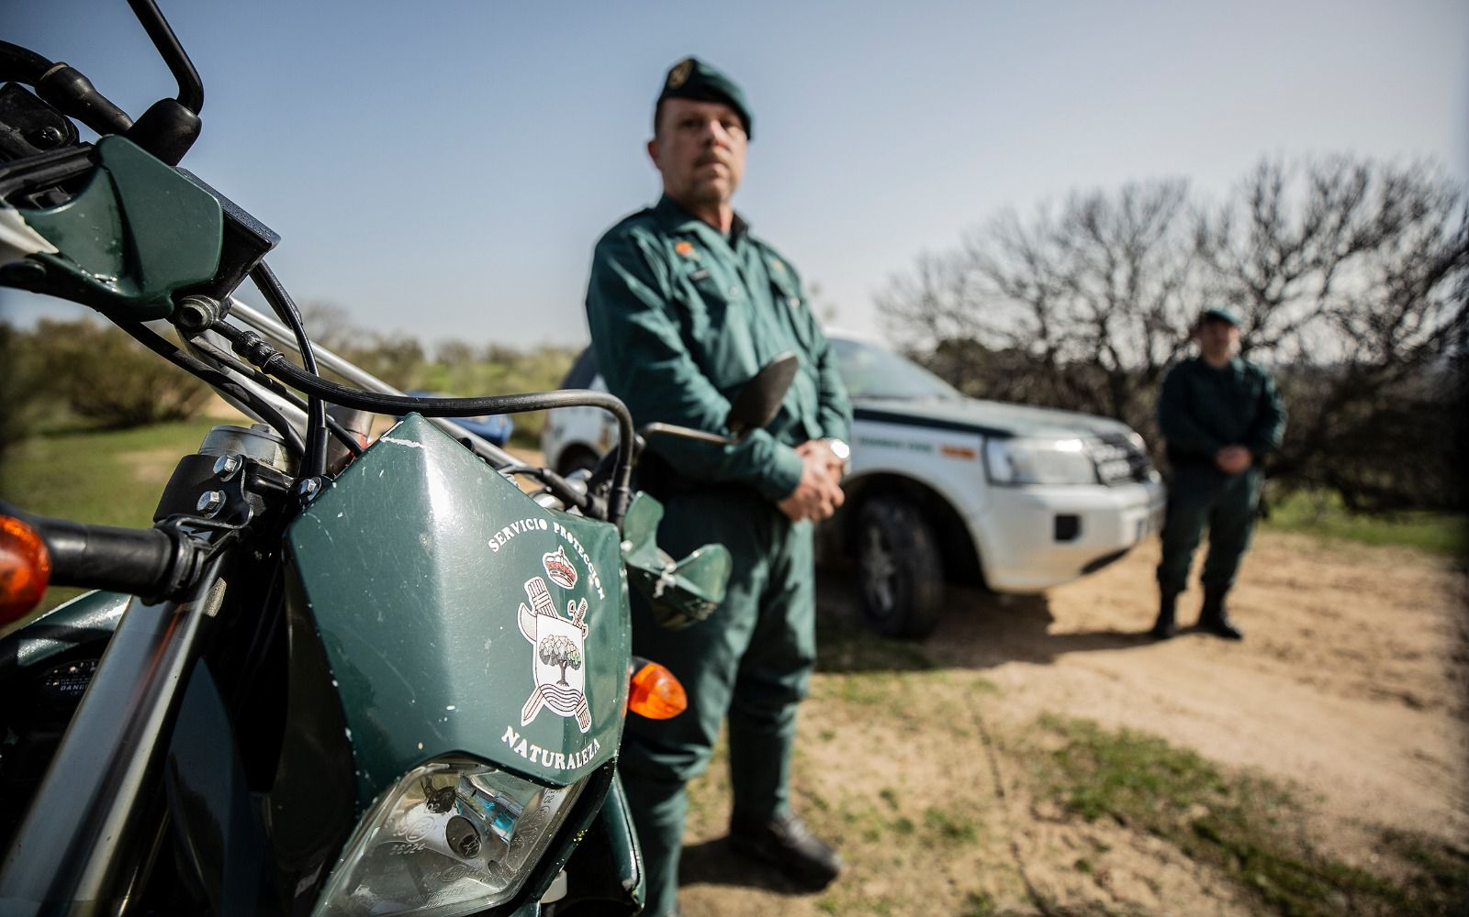

Royal Decree 734/2020, of 4 August, which develops the basic organic structure of the Ministry of the Interior, assigns to the "DIRECCIÓN GENERAL DE LA GUARDIA CIVIL", through the Head of the Nature Protection Service, the competence to plan, promote and coordinate, within the scope of the competences of the Civil Guard, compliance with the provisions related to nature and environmental conservation, protected areas, water resources, hunting and fishing, mistreatment of the environment, hunting and fishing, mistreatment of the environment and the protection of the environment, promoting and coordinating, within the scope of the powers of the Civil Guard, compliance with the provisions relating to the conservation of nature and the environment, protected areas, water resources, hunting and fishing, animal abuse, archaeological and palaeontological sites and land use planning. The National Central Office for the analysis of information on illegal environmental activities will report to this office.
Organised crime, which is kept out of the public eye due to the opaque nature of its activities, poses a considerable threat to Europe's citizens, businesses and state institutions, as well as to the economy as a whole. As highlighted in the latest EU Serious and Organised Crime Threat Assessment (SOCTA 2021), organised crime groups exist in all Member States. Organised crime is characterised as an interconnected environment in which criminals cooperate in a fluid and systematic way, always seeking to make a profit. Organised crime groups use their huge illegal profits to infiltrate in the legal economy and public institutions, including through corruption, thereby eroding the rule of law and fundamental rights and undermining people's right to security and their trust in public authorities.
In 2019, the revenue generated in the nine main criminal markets in the European Union amounted to €139 billion, equivalent to 1% of the Union's gross domestic product. As underlined in the Strategy for a Security Union, measures taken at EU level to support Member States in the fight against organised crime need to be "continued and strengthened".
The use of violence by OC actors in the EU is becoming increasingly common, and the threat of violent incidents due to the frequent use of firearms or explosives in public spaces is also on the rise. The agility of OC groups to adapt to and capitalise on changes in the environment in which they operate has been demonstrated during the COVID-19 pandemic. OC groups have taken advantage of the pandemic to expand their online criminal activities and commit fraud, notably counterfeit medical products.
The sustained high demand for COVID-19 vaccines is an attractive target for criminals willing to engage in the production and supply of counterfeit vaccines or to participate in fraud schemes targeting individuals or public authorities. To date, EU governments have detected attempted scams and bogus offers by fraudsters who have tried to sell more than 1.1 billion doses of vaccines for a total price of more than €15.4 billion. The economic crisis caused by the pandemic increases the risk of organised criminal activities and their further infiltration of society and the economy.
Transnational threats and the evolving modus operandi of organised crime groups operating online and offline require a more targeted and tailored coordinated response. While national authorities on the ground are at the forefront of the fight against organised crime, action at Union level and global partnerships are essential to ensure effective cooperation and exchange of information and expertise between national authorities, backed up by a common framework of criminal law and effective financial means.
Furthermore, organised crime is illustrative of the relationship between internal and external security. Addressing this transnational challenge requires international commitment to tackling organised crime, including taking further steps to develop partnerships and cooperate with countries in the immediate neighbourhood and around the world.
Both the European Parliament and the Council underlined that organised crime causes enormous damage and stressed the importance of taking firm action at EU level to combat organised criminal activities in all their forms.
This strategy builds on past achievements, identifies priority lines of work to better protect citizens and the economy from organised crime groups, and sets out concrete medium and long-term measures to be developed in full respect of fundamental rights. It is the first strategy to focus on organised crime since the entry into force of the Lisbon Treaty.
Particular attention should be paid to environmental crime, as it has harmful effects on biodiversity and the environment, health and social cohesion in the EU and in third countries. Illegal trade in all types of wildlife - plants, animals and their derivatives - and pets continues, often on a large scale and with potentially devastating consequences. Illegal waste management and transport undermine legitimate waste treatment and recycling industries.
The EU has adopted legislation aimed at regulating the legal trade in wildlife and waste, and required Member States to criminalise and sanction a wide range of environmental offences. The 2016 EU Action Plan against Wildlife Trafficking and the 2018 Environmental Compliance and Governance Action Plan have complemented these legislative instruments. The European Anti-Fraud Office has significantly enhanced its operational activities in the fight against illegal trade in products that pose a risk to the environment.
Despite these efforts, enforcement, law enforcement and judicial authorities often lack the capacity and resources to effectively detect, investigate and prosecute environmental crime. This is particularly the case in those Member States that do not have specialised law enforcement or judicial bodies or a strategic approach to combating environmental crime.
There is a need to strengthen law enforcement capacity at national and Union level. Penalties imposed are not sufficiently dissuasive, and co-ordination and exchange of information within and between Member States, in particular between administrative authorities and law enforcement agencies, is insufficient. The Commission is reviewing the Waste Shipment Regulation and the EU Action Plan against Trafficking in Wildlife. The Environmental Crime Directive will be revised to clarify the scope of environmental crime, to provide more precision in terms of sanctions, to facilitate the use of effective investigative tools and to boost cross-border cooperation and information exchange.

SEMINAR OBJECTIVES
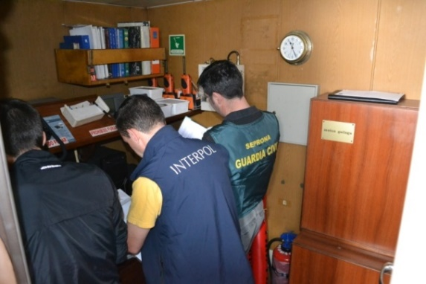

The aim is to hold an activity entitled "SEMINAR TO ANALYZE AND PROMOTE THE PRIORITIES IDENTIFIED BY THE EUROPEAN COMMISSION IN THE EUROPEAN UNION STRATEGY AGAINST ORGANISED CRIME 2021-2025 IN ENVIRONMENTAL MATTERS", starting on "07/11/2023" at "09:00h", and concluding on "08/11/2023" at "14:00 h", in the Hotel NH Eurobuilding in the city of "MADRID" in the province of "MADRID".
An estimated participation of "65" delegations is foreseen, resulting in a total of "65" persons. As attendees, 55 non-national representatives (44 EU representatives and 11 non-EU representatives) and 10 nationals are expected to attend, whose participation is justified because, on the one hand, with regard to the 55 non-national representatives, the aim is to have the maximum international participation of the most prominent experts in this field of crime. On the other hand, Spain, through SEPRONA of the Guardia Civil, is the founder of the JAGUAR NETWORK, a network aimed at coordinating, analysing and disseminating all cross-border information on environmental crime between South America and Europe. That is why the BOARD representatives of this network have been invited to present our country as a reference in international police cooperation in this field.
With regard to national representatives, experts from the Ministry of Ecological Transition (various sub-directorates involved) as well as members of the Guardia Civil (SEPRONA) and the National Central Office for the Environment will be present.
It will be organised by the "DIRECCIÓN GENERAL DE LA GUARDIA CIVIL".
This activity will seek to promote existing actions (as well as develop new ones) to achieve the objectives set by the Commission in the Strategy against Organised Crime 2021-2025.It will seek to strengthen existing capacities, and identify new modus operandi and criminal dynamics, particularly to detect and dismantle criminal networks, in relation to environmental crime, animal abuse, and related criminal activity. This will be addressed in a major event (or seminar), which will emphasise public-private partnerships (EnvicrimeNet, EMPACT, El PAcCTO...).

IMPULSE
the implementation of common training actions to promote linguistic immersion, intercultural knowledge and interoperability, with a view to creating a common European environment, made up of police training centres.
PROPOSE
Joint strategies for action to combat environmental crime in both the European Union and Latin America.
EXPLORE
ways of developing joint police cooperation between police forces of Member States of the European Union in environmental matters.

EXHIBIT
The experience gained in the activities that have been carried out in the fields of joint training and operational collaboration.
INCREASE
training activities offered to countries and regions considered to be of interest to EU Internal Security, both in the field of specialisation and postgraduate higher education, with a view to improving law enforcement response in both Europe and Latin America in areas of environmental crime.
JOINING IN
proposals for future lines of action on joint police training as an instrument for improving the EU's internal security and projecting the EU's external action in Latin America.

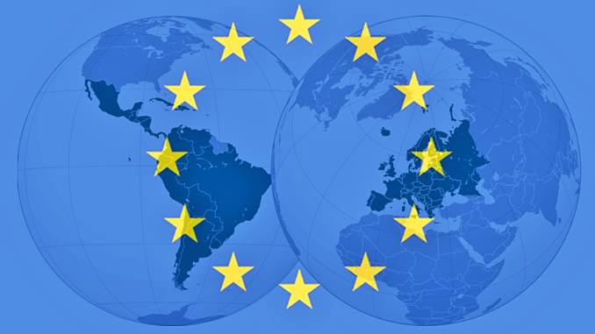

PROGRAMME OF ACTIVITIES
TUESDAY, 07 November 2023
08:45-09:15 h | Registration and welcome coffee
OPENING SEMINAR
09:15 – 09:30 h | Opening and welcome  Mr. Leonardo Marcos González  THE DIRECTOR GENERAL OF THE GUARDIA CIVIL
THEMATIC CONFERENCES
09:40-10:00 h | - (NOMBRE DE LA PONENCIA)  - GUARDIA CIVIL SEPRONA  (BRIGADIER GENERAL DAVID BLANES GONZÁLEZ)  - Questions
10:00 – 11:00 h | - COMISIÓN EUROPEA  i. DG-ENVI (NOMBRE DEL PONENTE)  ii. DG-SANTE (ALICJA MUZNIK)  - DG-HOME (NOMBRE DEL PONENTE)  - Questions
11:00 – 11:30 h | Coffee break
11:30 – 12:00 h | - (NOMBRE DE LA PONENCIA)  - Council of State (ENRIQUE ALONSO)  - Questions
12:00 – 12:30 h | - (NOMBRE DE LA PONENCIA)  - INTERPOL (SALVADOR ORTEGA)  - Questions
12:30 – 13:00 | - (NOMBRE DE LA PONENCIA)  - UNODC (NOMBRE DEL PONENTE)  - Questions
13:00 – 14:30 h | Lunch Brake
ROUND TABLES
14:30 – 15:30 h | - ROUND TABLE. EUROPEAN NETWORKS  - ENVICRIMENET (ONDREJ KOPOREC)  - IMPEL (ANA GARCIA)  - ENPE (MAKSYM POPOV)  - EUFJE (FAUSTINO GUDIN)  - Questions
15:30 – 16:00 h | Coffee break
16:00 – 17:00 h | - ROUND TABLE. EUROPEAN AGENCIES  - FRONTEX (NOMBRE DEL PONENTE)  - EUROPOL (JEAN PHILIPPE LECOUFFE)  - EUROJUST (NOMBRE DEL PONENTE)  - OLAF (MIGUEL ÁNGEL GODOY)  - Questions

WEDNESDAY, 08 NOVEMBER 2023
THEMATIC CONFERENCES
09:00-09:30 h | Registration and welcome coffee
09:30-10:00 h | - (NOMBRE DE LA PONENCIA)  - RED JAGUAR (MIGUEL ÁNGEL GARCÍA LÓPEZ)  - Questions
10:00-10:30 h | - (NOMBRE DE LA PONENCIA)  - MITERD (NOMBRE DEL PONENTE)  - Questions
10:30-11:00 h | - (NOMBRE DE LA PONENCIA)  - WWF (EVA GUTIERREZ IZQUIERDO)  - IFAW (BIANCA BECHERER)  - Questions
11:00 – 11:30 h | Coffee break
11:30-12:00 h | - (NOMBRE DE LA PONENCIA)  - El PAcTO (JUAN GAMA)  - Questions
12:00-12:30 h | - (NOMBRE DE LA PONENCIA)  - OCN (LUIS ALBERTO MADERO)  - Questions
CLOSING CEREMONY
CONCLUSIONS
12:30-13:00 h | Closing  Mr. Fernando Grande Marlaska  Minister of the Interior
13:00-14:00 h | Cocktail

