

***iDEPEND***

|  |  |
| --- | --- |
| Guidance  Inspectionshttp://www.coolangus.com/wp-content/uploads/2013/04/making-the-right-choice-making-better-choices-making-bad-choices.jpg | Market Mechanisms |

***iDEPEND*** – A Guide

|  |  |
| --- | --- |
| IMPEL | Decision Aid for Choosing Effective Regulatory Interventions |

ABOUT IMPEL

The European Union Network for the Implementation and Enforcement of Environmental Law (IMPEL) is an international non-profit association of the environmental authorities of the European Union Member States, acceding and candidate countries of the EU, EEA and EFTA countries.

[](http://impel.eu/wp-content/uploads/2012/10/IMPEL-map-4.png)

The association is registered in Belgium and both its legal seat and its Secretariat are in Bruxelles, Belgium. Currently IMPEL has 47 members from 33 countries including all EU Member States, Croatia, the former Yugoslav Republic of Macedonia, Turkey, Iceland, Switzerland and Norway.

IMPEL was set up in 1992 as an informal Network of European regulators and authorities concerned with the implementation and enforcement of environmental law. The Network’s objective is to create the necessary impetus in the European Union to make progress on ensuring a more effective application of environmental legislation. The core of the IMPEL activities concerns awareness raising, capacity building, peer review, exchange of information and experiences on implementation, international enforcement collaboration as well as promoting and supporting the practicability and enforceability of European environmental legislation. The Association undertakes its activities primarily within a project structure.

IMPEL has developed into a considerable, widely known organisation, being mentioned in a number of EU legislative and policy documents, e.g. [the Decision No 1386/2013/EU of the European Parliament and of the Council of 20 November 2013](http://eur-lex.europa.eu/legal-content/EN/TXT/PDF/?uri=CELEX:32013D1386&from=EN)on a General Union Environment Action Programme to 2020 ‘Living well, within the limits of our planet’, laying down the Seventh Community Environment Action Programme, [the Recommendation 2001/331/EC of the European Parliament and of the Council of 4 April 2001 providing for minimum criteria for environmental inspections in the Member States (RMCEI)](http://impel.eu/wp-content/uploads/2010/01/RMCEI-2001-331-EC.pdf), [the Communication from the Commission to the European Parliament, the Council, the European Economic and Social Committee and the Committee of the Regions on implementing European Community Environmental Law](http://impel.eu/wp-content/uploads/2010/01/Communication-on-implementing-European-Community-Environmental-Law-2008-com_2008_773_en.pdf) and [the European Commission Impact Assessment Guidelines](http://impel.eu/wp-content/uploads/2010/01/European-Commission-Impact-Assessment-Guidelines-iag_2009_en.pdf).

# Foreword

The European Union’s 7th Environmental Action Plan sets out environmental priorities and outcomes up to 2020. But success in achieving these outcomes depends on member states and organisations having the right means to deliver them including legislation and tools.

Environmental regulation has achieved a lot using traditional methods such as permitting, site inspection and enforcement. But if we want to do more to improve compliance and environmental performance, using these methods may not be the only, or the most effective, means.

There are many other types of intervention that can be used alongside, or as alternatives, to direct, state led regulation.

The complex and interdependent nature of the environment, business and regulation means conventional methods of analysing environmental risks and choosing appropriate ‘counter measures’, or ‘interventions’, may not be effective.

The IMPEL Network has been established to help drive more effective implementation of environmental legislation in the EU. The Choosing Appropriate Interventions project is part of IMPEL’s work program to achieve this objective.

The project has sought to provide environmental regulators with a practical tool to help them make the right choice of intervention. And it has sought to encourage IMPEL members to share good practice and experience in choosing, using and evaluating interventions.

The project has posed this question - *even if we know about different types of intervention, how can we choose the right ones according to circumstances and what might we use to help us make those decisions?*

*iDEPEND* has been identified and developed as a decision support tool to help environmental practitioners choose the most appropriate interventions. It is a dependency modeling tool which uses a structured and verifiable approach to identify which factors, or dependencies, are most important to achieving a goal or outcome. It can be applied at different levels, for example to help develop national strategies or to formulate site-based action plans.

*iDEPEND* has been used for several applications, but the *iDEPEND* version available to IMPEL members and this *iDEPEND* guide have been specifically developed for IMPEL for the purpose of choosing interventions.

This guide sets out how to use *iDEPEND* to help choose the right types of intervention to improve the environmental compliance and performance of business and other organisations. As well as this guide, a webinar[1] is available to view which demonstrates a model being developed, reports run, interventions added etc.

I hope that you will find the *iDEPEND* tool and guide a useful addition to the environmental practitioner’s toolkit.

Duncan Giddens - Senior Business Advisor at the Environment Agency in England and manager for the IMPEL Choosing Appropriate Interventions project

Contents

Foreword 3

1. Introduction 8

1.1 The issues facing regulators and why they are trying to find the best interventions. 8

1.2 The need to support decision making and find a tool to help. 8

1.3 Dependency modeling. An aid to decision making. 8

2. Choosing Appropriate Interventions 10

2.1 Examples of Intervention types 10

2.2 Factors to take account of when you choose interventions. 10

2.3 The process of choosing interventions 11

3. *iDEPEND* 12

3.1 Principles of the iDEPEND tool. 12

3.2 An aid to decision making 13

4. Using *iDEPEND* to help choose interventions 15

4.1 Main features and “views” of the iDEPEND application. 15

The Dashboard Page 15

The Models Page 16

Models Panel 16

Entities Panel 16

Reports Panel 17

History Panel 17

More Panel 17

4.2 Creating “entities” 17

Define your first entity – your goal or “desired state”. 17

Dependencies 18

Interventions 18

4.3 Building a model 19

Dragging and dropping entities 19

Association type (“and” / “or”) 19

Probability values 20

4.4 Reports 21

The Reports Panel 21

All Probabilities Report 21

Three Point Sensitivity Report 21

Failure Mode Report 22

Producing the Reports 22

Updating of Reports 23

4.5 Interventions 23

4.6 Iterations 24

Moving and removing entities from the model 24

Modules 25

4.7 Using and Creating Templates 25

Using Template models 25

Creating Template Models 25

Using Template interventions – and links to evidence sources 25

Creating Template Interventions from individual entities. 26

4.8 Grouping, Sorting and Filtering Entities 26

4.9 Deleting 26

Two-Step Delete Links 26

Deleting an Entity 26

Deleting a model 27

5 Saving, exporting and sharing *iDEPEND* models and reports 28

5.1 Saving a model: “Undo and redo” 28

Automatic saving of versions 28

User controlled saving 28

5.2 Exporting a model or report 28

As JPG file 28

As xml file 28

5.3 Sharing with other users. 28

5.4 Being Followed and Following 29

Being followed 29

Following 29

Stopping Following or Being Followed 29

6. Sharing experiences of using and evaluating interventions 30

6.1 Building a Community of IMPEL’s iDEPEND users 30

6.2 The Regulatory Evidence Network 30

6.3 Using and evaluating interventions 31

7. Support and Resources 32

7.1 Interventions. 32

7.2 Models 32

7.3 Help on using 32

Guidance for more advanced modeling can be downloaded from these links: http://www.cambrensis.org/wp-content/uploads/2012/05/DependencyModellingTheBetterwayCam.pdf 32

7.4 Using iDEPEND after the end of 2014 32

Appendix 1. An example of an *iDEPEND* model to support choosing interventions. 33

Without Interventions. 33

With Interventions 34

# Introduction

## 1.1 The issues facing regulators and why they are trying to find the best interventions.

Inspections have traditionally been used as the tool to ensure compliance with (EU) environmental legislation. Increasingly regulators are using a range of different complementary approaches in addition to inspection to help drive compliance and delivery of desired outcomes. IMPEL has undertaken projects to determine:

1. where and how complementary approaches to inspections have been used[2]; and
2. how the most effective interventions (inspections and other approaches) can be selected and used[3].

## 1.2 The need to support decision making and find a tool to help.

IMPEL recognized that the process of choosing interventions was a very difficult task because

* the success of particular interventions seem to be dependent on particular circumstances;
* the evidence available about each intervention is limited and difficult to find.
* the “systems” in which regulators operate are complex and multivariable.

Meanwhile:

* the Regulatory Evidence Network[4] (REN) has been established to provide evidence about a range of interventions and about what factors to take account of in choosing interventions
* dependency analysis has developed and is being used as an aid to decision making in other spheres operating within complex systems.

So IMPEL decided to look at dependency analysis and see how it could be used to help IMPEL members choose interventions, evidence about which has been made available on the REN.

## 1.3 Dependency modeling. An aid to decision making.

Apart from death and taxes, so the saying goes, nothing in this life is truly certain. Equally no physically possible event can be dismissed as having zero probability. So in real life we have to cope with making decisions under uncertainty, somehow “guestimating” the “odds” to help us rationalize our “instinctive” preferences.

But for important decisions, transparency, governance and integrity all demand a more responsible approach and we need a more rigorous justification of the basis of any evidence used. This is especially true in complex multivariable systems where achieving your goal is dependent on a number of factors which might be of very different types such as legal, financial, technical and behavioural factors.

A new *Objective Driven, Dynamic, Dependency Defining* approach is now available to us – “***Dependency Modeling” -*** (now an Open Group Standard[5]). A Dependency Model is a **goal** centric model of a system. A system in this context could be anything from an actual mechanical system, to a computer system or business process. It could well mean a more abstract concept such as personal well-being.

A Dependency Model consists of a collection of “entities” arranged in a hierarchy. A model usually has one “root” entity which represents the core goal of the system. By “building” a model to represent your system and “running” it to predict the chances of achieving your goal you can test out the resilience of the world “as it is” and then make changes to see how you can increase your chances of success and thereby improve the resilience of the whole “system”.

# Choosing Appropriate Interventions

## 2.1 Examples of Intervention types

Regulators have applied numerous interventions to improve compliance and/or achieve wider environmental aims. These typically fall into 5 or 6 categories as shown in box 1.

|  |
| --- |
| **Box 1. A typology of interventions**   * **Direct regulation:** relatively certain outcome but potentially costly, need to be targeted according to risk e.g. Environmental Permitting regime, REACH * **Economic instruments:** less certainty of outcome but greater flexibility for businesses to choose least cost options, may provide long-term certainty e.g. Landfill Tax * **Information based approaches:** uptake dependent on customer/supply chain interest e.g. EU Ecolabel * **Co-regulation:** can encourage rapid action, flexible to changing circumstances, but may struggle to capture small businesses e.g. Courtauld Commitment * **Self-regulation:** action motivated by financial, customer/supply-chain or reputational influences e.g. ISO14001 * **Support and capacity building:** impact may depend on credibility and trust.   Source: Taylor CM, Pollard SJT, Angus AJ & Rocks SA. (2013)[6] |

The IMPEL complementary approaches report[7] included brief descriptions of about twenty five interventions (at section 4 on pages 8 to 14).

A summary of evidence for choosing interventions produced for the Regulatory Evidence Network[8] includes a list of about 30 interventions with examples of where each has worked and why, with links to evaluations or other evidence for each (see table 2-8 on pages 20 to 30 of that report).

## 2.2 Factors to take account of when you choose interventions.

Phase 1 of the projectconsidered how one might choose interventions according to circumstances to achieve environmental outcomes. The project developed a model approachrepresented by the diagram at figure 1.

**Figure 1**



## 2.3 The process of choosing interventions

Although figure 1 appears to show a simple process, the task of actually choosing interventions according to relevant circumstances is not a simple task nor a precise operation with obvious clear process steps to follow. Recent work in the UK by Defra[9] concerning this issue will be of help in this regard. However the task still requires users to have good (but not perfect) knowledge of the factors which affect choice of interventions and some way of assembling these in a way that helps support that decision making. So, IMPEL have investigated and demonstrated how dependency analysis might help to address this problem. This guide shows how IMPEL users can use a particular dependency modeling tool, “*iDEPEND”,* to act as a decision support tool for choosing interventions.

# *iDEPEND*

## 3.1 Principles of the *iDEPEND* tool.

*iDEPEND* is a dependency modeling tool. It has been used for several applications but this guide focuses on its application to support the choice of interventions by IMPEL members. It is available on the web for IMPEL members (rather than downloadable to your computer). IMPEL members with an up to date web browser[10] can access it by clicking [here](http://idependeu.herokuapp.com/)[11] and signing in for an account.

This tool has a different (novel) “Top-Down” approach to risk, as it allows “on-screen” composition and editing of models and aims to create an overall framework to knit together a set of prerequisite conditions – dependencies – which the user can create, or choose from templates. The problem is first represented as a visual model on screen which *then*

* treats it as a Bayesian network[12] from which it makes statistical inferences, and
* forecasts the probability of achieving your goal
* produces sensitivity analysis reports
* provides a failure-mode model to extract failure modes.

So *iDEPEND*is a tool for analysing what a *successful outcome* of a process really depends on in any system, be it an organisation, endeavour, enterprise, infrastructure, business, factory, machine, decision, plan or idea - anything in fact for which a suitable model can be built. It works by analyzing the model**.**

*IDEPEND* is thus concerned with *goals*. A goal can be anything from avoiding disasters to successfully making the right decision, or launching a new enterprise

An *iDEPEND* model represents the goal plus the things that achieving it depends on, plus the things those things depend on, and so on. A simple example is shown in figure 2.

Once a “goal” has been defined and a dependency model has been constructed on *iDEPEND* then *iDEPEND* can help you to:-

* predict the probability of achieving goals
* predict the risks to those goals
* find those dependencies which are most pivotal to goals and on which you need to focus
* predict which dependencies are the most likely causes of success and failure
* thereby showing you where you might apply “countermeasures” (or interventions)
* predict the effectiveness of those interventions on achieving your goals
* and thereby find ways to reduce risk and increase resilience in the “system” you are trying to manage to achieve your goals.

**Figure 2. A simple dependency model. A first set of example dependencies is shown and branches are shown to further dependencies which may be added.**

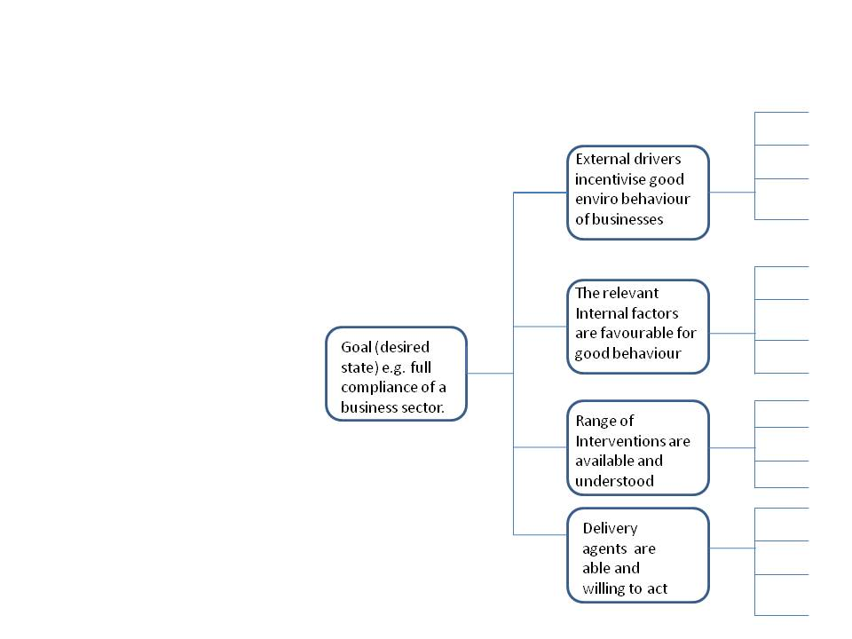

## 3.2 An aid to decision making

The *iDEPEND* tool is an aid to *your* decision making and your recording and explanation of your decisions rather than a substitute for it. It works by *supporting* your thinking and setting that out in a way which helps *you* to *consider* the dependencies to achieving your goal and how they fit together in a model that it helps *you* construct. Once you have run the model it will also help you to identify which areas to focus your attention on and help *you think through* what particular interventions might best address those dependencies which most threaten achievement of your goal.

It needs you to be knowledgeable about your own particular situation and about your organisation, other organisations and the interventions that can be applied. The tool is not a substitute for this knowledge but a means by which you can apply that knowledge to find and test solutions. In this regard it helps you collect, input and link information in a way that helps you reach your decision as well as keeping a record of the inputs and predicted outputs.

The quality of any decisions that you come to over interventions will be related to the structure of your dependency model, the accuracy of the “and/or” states and on the probabilities that any one dependency affects another. In other words how well you have described and quantified the inter-relationships between factors. Evidence is available on some of these factors (as described in section 2) but much of it will have to be the expert judgment of the user and colleagues. It will often be a good idea to gather together a group of experts to work together on this exercise. The dialogue and the exploration of what the “system” looks like as well as estimation of the probabilities may be as valuable as actually building and running a model.

The *iDEPEND* tool is not a substitute for expertise and thinking but is an important aid that can support your use of expertise and thinking to make decisions over interventions. Like any other decisions where you have imperfect information you have to use the best information you have, but of course that can never be perfect.

# Using *iDEPEND* to help choose interventions

## 4.1 Main features and “views” of the *iDEPEND* application.

The web address for the *iDEPEND* tool for IMPEL users is <http://idependeu.herokuapp.com/>. It is best accessed via the Mozilla Firefox browser but also works on Google Chrome, or later versions of Internet Explorer (version 10 or above).

Once you have entered your necessary details to set up an account and if you belong to an organisation in the IMPEL network then you will gain access to use the *iDEPEND* application on line. There are two core sections to this application;

* the [Dashboard](http://idependeu.herokuapp.com/help) page. This is the first page you will see after signing in. It is where you can get an overview of your models and other data: and
* the [Model Pages](http://idependeu.herokuapp.com/help) where you do your actual dependency modeling work. On the models pages you can see entities, models and reports.

### The Dashboard Page

The Dashboard is the central control point in the application. From here you can see an overview of your data and access all the other parts of the system.

The right hand side of the Dashboard is divided into a number of sections.

* The “Recent History” section shows your recent activity and can be clicked to return to any particular model, entity, reports etc.
* The “Your Data” section shows your usage and what your limits are.
* The “Shared Data” section shows which other users you are sharing models with.

On the left hand side of the Dashboard is the “Models List” where you can view your existing models. Click on any of these to go to the models page.

**Figure 3. The Dashboard Page.**

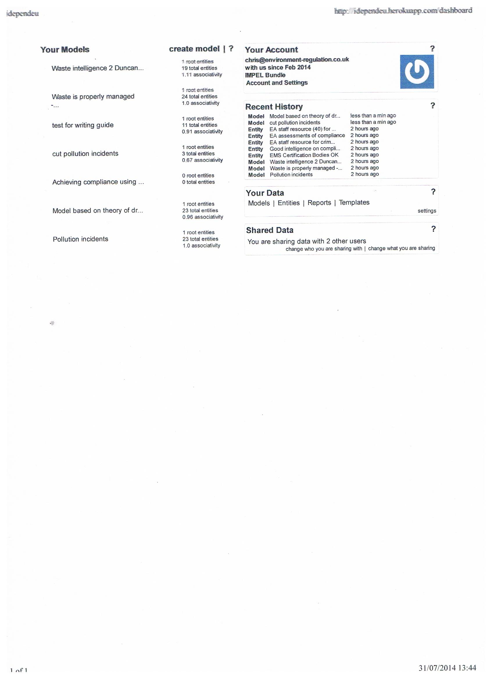

### The Models Page

In the models page the application uses the full width of the browser window and the content is divided in to ‘panels’. See figure 4. The other panel types are shown above the model: entities panel; reports panel; history panel; and more panel. These can be moved around to change their order and toggled on and off by clicking the relevant panel title. Each panel serves a different function as described below:

**Figure 4. The Models Page.**

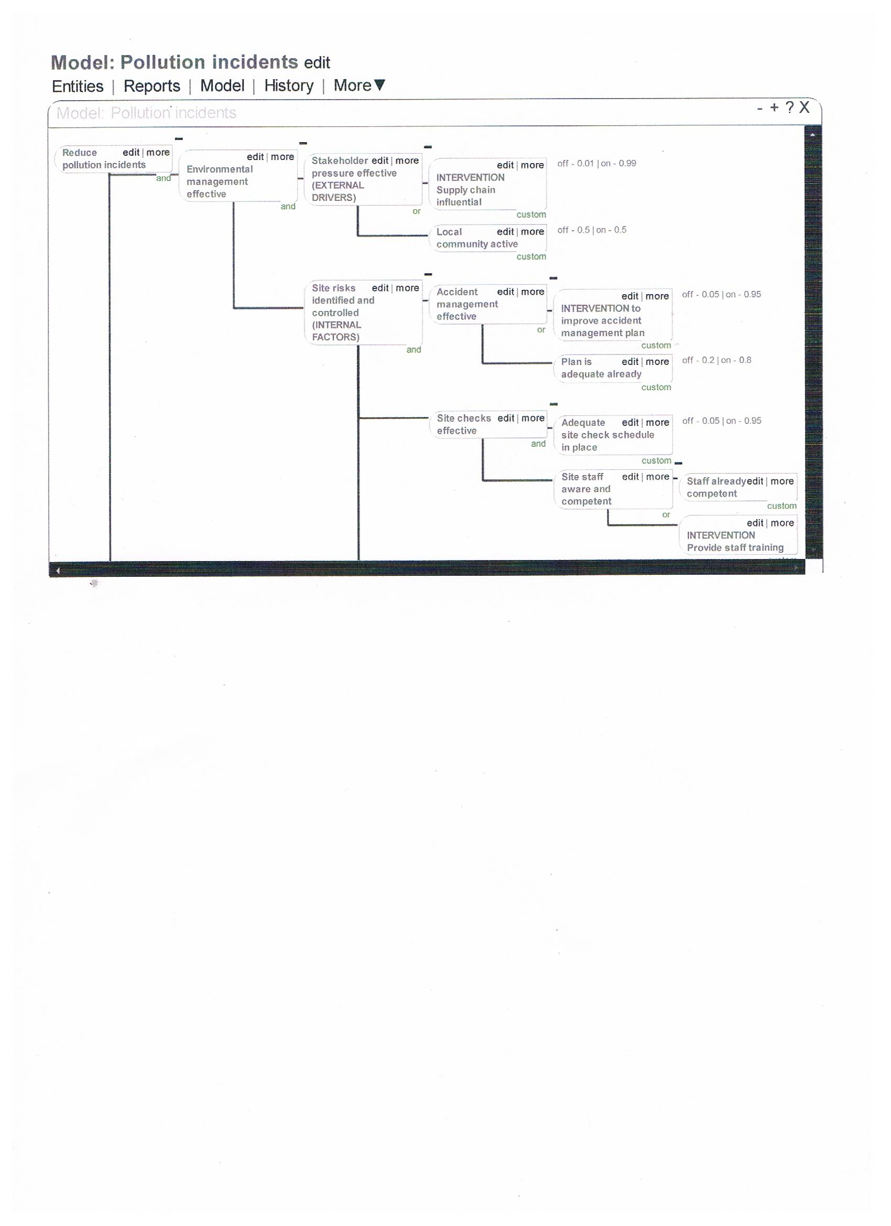

### Models Panel

The main **Models Panel** contains the actual model you are working on (See section 4.3) and provides you with access to the other panels, each of which provide additional features and are summarized below.

### Entities Panel

The **Entities Panel** holds your existing entities so you can select them for use in the model. Entities are the core unit to building models. They can be used to represent anything from tangible components to abstract concepts. For the purposes of this guide the entities will be either the goal, the dependencies, or interventions. See section 4.2

### Reports Panel

Generated reports are kept in the **Reports Panel** and each report will open in its own panel. Reports of several kinds can be created for model and these tell you about different aspects of the model and describe vulnerabilities visually. See section 4.4

### History Panel

This shows previous versions of the model you are working on. See section 5.1

### More Panel

This takes you to a list of interventions you have saved (see section 4.5 and 4.7) and to the export functions –See section 5.2.

## 4.2 Creating “entities”

There are essentially three types of entity in a dependency model:

* The “root” entity. This is the particular “goal” or desired state for which you wish to use dependency modeling to help you achieve.
* Dependencies. Things that achievement of your goal are dependent upon.
* Countermeasures (in our case interventions applied to regulated business). It can be a regulatory or non-regulatory intervention applied by government, the regulators or by other organisations.

Any entity at the “end” of branches of other entities is called a “leaf”

### Define your first entity – your goal or “desired state”.

You need to name and add a description of you first “root” entity. This is your goal or desired state that you want to achieve. The *iDEPEND* tool for IMPEL users has some template models with general description of a goal but you should be much more precise. Some examples could be:

“air emissions at a cement plant are within environmental permit limits”

“the chemical sector is compliant with environmental law”

“water quality objectives for a region/catchment are met”.

On the dashboard page, click “Create model” and then enter a model name. You can start from a blank page or create your model from one of the templates (see… below). Once you name your model and click” create” you will be taken to the models page with 2 panels: the entities panel and the model panel.

**The entities panel** enables you to create and find entities, add them to your models as well as edit and destroy them. Entities can be created by typing a name[13] into the text box at the top and then clicking “add” or pressing the enter key. See figure 5.

Your goal is the first entity you will add to your model. So first of all enter a name of your goal, click “add”. The new entity will appear in the entities list and will be highlighted for a few seconds. Click on it and then click on “edit” to add a more detailed “description” below the name. If you don’t want to edit it yet you can do so at any time. See figure 5.

**Figure 5. The model panel with an example “Root” entity added**



### Dependencies

Consider the evidence[14] you have about what things are required to satisfy your goal. So for example that might be things like:

* the internal and external characteristics of the business(es) in question
* a competent set of bodies to deliver interventions
* the particular objectives you want to achieve

Of course the tool can be applied to whatever set of dependencies you think are most important. For example it has been used by applying the “Table of 11”[15] factors as dependencies or by adding specific “real world” dependencies appertaining to the issue in question.

Dependencies can be created by typing a name[16] into the text box at the top of the entities panel and then clicking “add” or pressing the enter key. The new entity will appear in the entities list and will be highlighted for a few seconds. Click on it and click edit to add a more detailed “description” below the name if you wish. If you don’t want to edit it yet you can do so at any time.

### Interventions

Interventions are added to the model just as another type of entity. You may have your own “stock” of interventions or you may wish to refer to the compilations of list of interventions referred to in sections 1 and 2. To make things easier there is a list of template interventions in *iDEPEND,* each of which has a clickable link to more information, where it has been used and further sources of evidence about the intervention. See section 4.7 about using intervention types. Interventions are not normally added to a model until after you have built your first version and run reports. The way in which you add interventions is described in section 4.5.

## Building a model

### Dragging and dropping entities

To add the goal to a model simply drag it from the entities list and place it onto the model.

To add the first dependency to your model simply drag it from the entities list and place it onto the existing entity (in this case your goal). When placing directly onto another entity, the target entity will turn yellow to indicate you can drop your entity onto it.

Repeat this for the other “first order” dependencies that your goal is directly dependent upon. See figure 6.

**Figure 6. The model panel with an example model with a set of “first order” dependencies.**

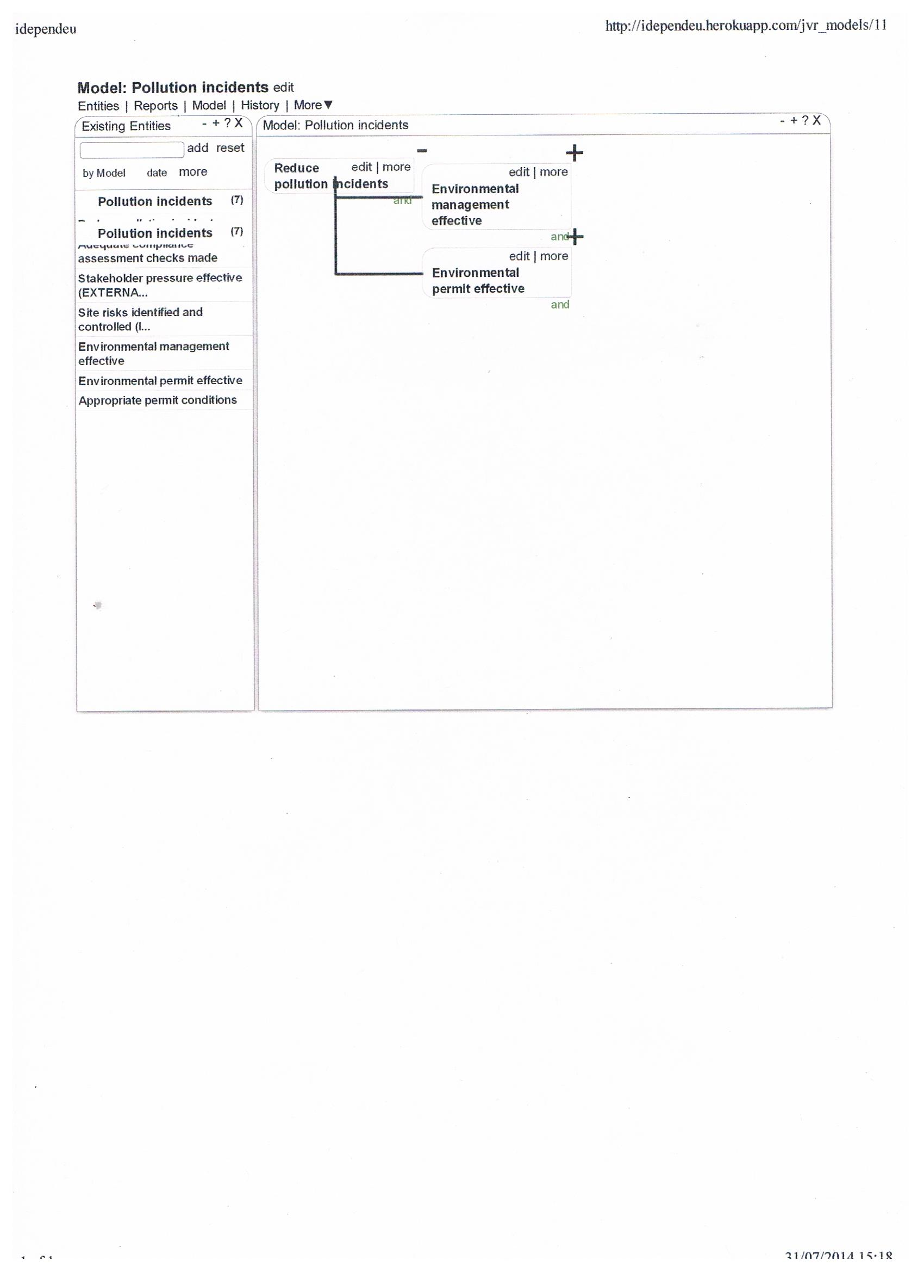

### Association type (“and” / “or”)

Once you have completed the set of first order dependencies you will need to consider if your goal is dependent upon every one acting together (an “and” relationship) or any individual one acting by itself (an “or” relationship). To set this up on the model you click “edit” on your goal and select the relevant “association type (“and”/”or”). See figure 7.

**Figure 7. Association type. This example set at “and”.**

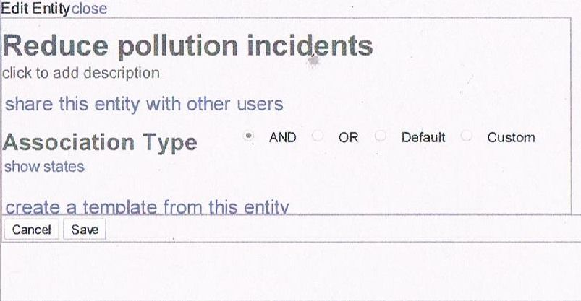

### Probability values

Having built your model to your satisfaction, you will shortly be able to forecast the chances of achieving your goal and where to focus your efforts to improve those chances. The final step you need to do before producing such reports is to enter the probability values of each of the final dependencies (or “leaves”) on each branch of your model. This means you will need to consider the likelihood that each of those leaves will cause the dependency on its left to be met. This is often the most difficult input that a user has to make. It will often be a good idea to gather together a group of experts to work together on this exercise. The dialogue and the exploration of what the probabilities might be could be as valuable as actually building and running a model.

To add or amend probability values, click “edit” on the particular leaf on the model and use the slider to adjust the probability. So, for example if you think that a dependency will be 80% effective, then move the slider so that it shows “on” as 0.8. (The “off” value will then automatically adjust to 0.2).The probabilities will change in increments of 5% (show as 0.05). See figure 8.

**Figure 8. Setting the probability values**

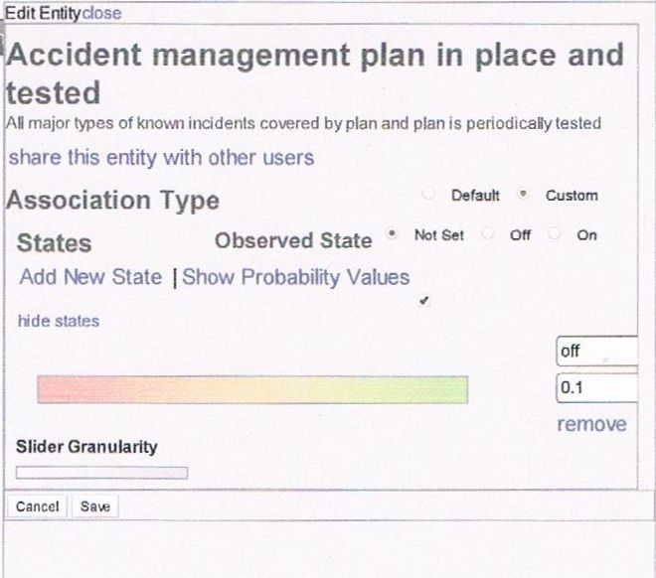

If you wish to be more precise then move the “slider granulatory” slide to the left to allow you to enter probabilities down steps of to 0.001 (0.1%).

## Reports

Once you have created all your entities, configured these on your model and determined the “association types “(and/or) and inserted probabilities then you can run reports.

### The Reports Panel

The **Reports Panel** displays the reports for any model and allows you to generate “default reports” for it. The three primary report types are:

* an “all probabilities report”;
* a “failure mode report”; and
* a “three point sensitivity report”.

### All Probabilities Report

This type of report uses the probabilities which you have assigned to the leaf entities and the “associations” you have defined to other entities to calculate the probabilities for all entities. When this report is displayed it will colour the entities in the model according to their probabilities. Appendix 1 shows the “all probabilities report” for 2 versions of the same model. The first one shown is a model without interventions added. As you can see, this model predicts that the goal is not likely to be met as shown by a mostly red shading of the goal on the left i.e. “reduce pollution incidents”. If you hover your mouse over the goal (or any other entity) while in *iDEPEND* then you can see the actual prediction of meeting the goal based upon the data you have put into the model.

### Three Point Sensitivity Report

This report returns a graphical representation of the significance that each leaf represents to the goal in terms of the effect their failure will have. The results of this report are shown in a separate panel. Figure 9 shows an example report. The model from which this report was made is the first one shown in appendix 1. This sensitivity report shows which of the “leaf” dependencies you should most apply interventions to in order to improve the chances of meeting your goal. The second model shown in appendix A has interventions added to address the top 5 “leaf” dependencies shown in figure 9.

**Figure 9. Example of a sensitivity report.**

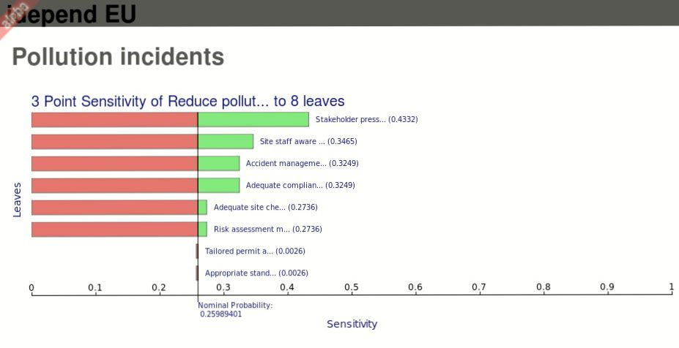

### Failure Mode Report

A failure mode report will calculate which combinations of failures of leaf entities will result in a failure of the goal in the model. The results of a failure mode report are displayed in a separate panel. Clicking on the various results in this panel will highlight the involved entities on the model.

### Producing the Reports

The app will try to ensure that there is always an “all probabilities” report present as this report is also used in other calculations. The other reports types can be created in a couple of ways;

Clicking the “make default set” link at the top of the reports panel (see figure 10) will ensure a report of each type for each root entity in the model.

**Figure 10. Producing and updating reports**

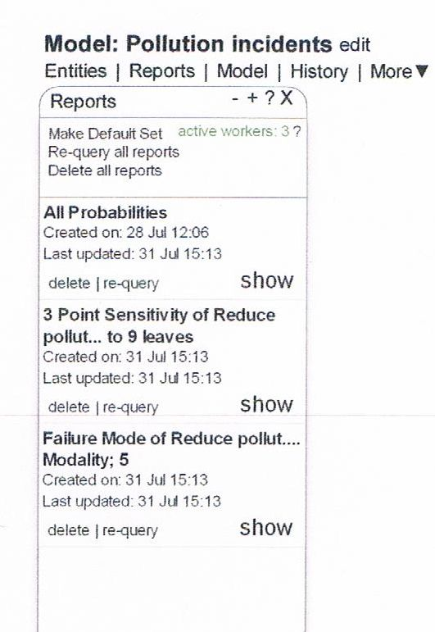

### Updating of Reports

To see any report simply click “show”. If you then alter the model click re-query report. Reports will automatically update to changes in the model if they are open. This allows you to see the effect of changes as you go and is particularly effective with the all probabilities reports.

Reports also cache their results so if the model returns to a previous state then the report will return a cached result. This makes toggling between a number of set states in the model for comparison very fast. It can also be advantageous for demonstrations as the results can be pre-cached in the reports. **Note** clicking “re-query” on an individual report will reset its cache. “re-query all reports” does not reset their caches.

Specific reports can be made for specific entities in the model (except leaves) by clicking the “more” link on an entity in the model and selecting “analysis” from the menu.

## Interventions

Once you have run the reports you will see which particular “leaf” dependencies are having the biggest affect on the achievement of your goal. Consider the “leaf” dependency which is most affecting the achievement of your goal from the sensitivity analysis report, and then include an intervention as a parallel leaf dependency which can act to negate its impact.

The easiest way to add an intervention is to create 2 leaf dependencies for the particular dependency you are addressing. One will typically be that the dependency is met without intervention and the other will be the intervention itself. These 2 dependencies will be of the “or” state of course. For example from figure 9 you can see the first “leaf” dependency to address would be “stakeholder pressure is effective”. In this case (as shown in the second model in appendix 1) you could add an Intervention such as making using the supply chain to influence environmental performance.

You can then run the model again immediately, or include further interventions for perhaps the 3 or 4 leaf dependencies which have come out on top in the sensitivity analysis, before running the reports again to show how the probability of achieving your goal has changed as a result of interventions applied.

## Iterations

You should run several iterations and constantly review and update your *iDEPEND* ‘models’. Only by doing this can you build confidence in yourself and others that you are expressing a reasonable view of reality as it is now and as it might be with interventions in place. In particular after running reports for the first time, you would normally wish to add interventions to your model and to see the effects of interventions on the chances of achieving you goal.

After you have gone through this once, you might want to look hard at the model and all its assumptions, make any amendments to model structure or probabilities and repeat it again. Subsequent iterations are to be expected. Remember though that you are not expected to build a perfect model nor are all the inputted probabilities expected to be highly accurate. However by sharing your thoughts with colleagues and continuously refining the model you should be able to get closer to something that is a reasonable representation of the issues and can provide you with support and an audit trail for decisions on interventions that you choose for a particular set of circumstances.

### Moving and removing entities from the model

At any time you can make changes as you see fit.

The move option allows you to change the position of the given entity.

* You can select to “Move to Root” which will make the entity a goal in the model.
* You can select to “Move Left” which will shift the entity one place to the left in the dependency network.

For example, if you had the model: A -> B -> C then clicking move left on C would make it a dependency of A.

A -> B

|--> C

You can also select a specific entity to move within the model from the list of entities. On the entities panel, just type “search” in the list, select an entity and click the link at the bottom or press enter.

The “remove” [17] option allows you to remove an entity from the model and allows you to choose how it is removed. You might have a model where one entity appears several times, i.e.:

A -> B -> D

| | -> E

|

|--> C -> F

| -> E

E is a dependency of both B and C.

To remove E from B, click remove and then just click “Confirm”.

* To remove E from both B and C, click remove, check the first checkbox “remove this entity from other dependents…” and the click “Confirm”
* You can also “exclude” E from the model by checking the second checkbox before clicking “Confirm”. Note – only one option can be checked at once.
* Excluding E from the model does not change its associations, it will still be a dependency of B and C but it will no longer be part of the model. Excluding any one dependency will also exclude its “co-dependencies”. In this case excluding E would also exclude D and F. The effect of this would be to make B and C act as if they were leaves, but unlike other leaves where the probability values are set by hand, these take their probability values from the calculations using D, E and F. D, E and F could now be made Roots in another model and in effect these models would be connected together.

### Modules

You may consider working on one part of the situation and save that individual “module” before working on other parts and then combine all modules later. Over time you might develop a number of standard modules that could be stored and then selected from a menu and combined as appropriate.

## 4.7 Using and Creating Templates

You can use templates to help you create entities and build your models and using existing models and entities which have been saved as Templates.

### Using Template models

When you choose ‘create model’ from the Dashboard page, you are asked for a model name and given the option to use an existing Template. The drop down list shows all the Templates that are already in all IMPEL users’ accounts and others that have been shared with you or that you have saved yourself. The new model will have all the entities and structure of the original Templates but you will have to set your own probability values. Of course you might also want to amend or delete entities to suit your own particular circumstances.

### Creating Template Models

On the dashboard, click the “Templates” link in the “Your Data” panel and then select “Model” under “New Template”. Then click “select a model” (to create a template from) and a drop down list of your models will appear. Add a title in the “Title” box for the template (make the temple title somewhat different to your model title to avoid confusion) and select the model from the drop down list and click “add”.

### Using Template interventions – and links to evidence sources

You can drag and drop entity templates which have been saved as Interventions onto an existing Model. These templates are listed in the Interventions panel found from the ‘More’ menu. If you drag a template intervention onto a model where it has already been used, then you will be presented with a choice. You can either use the “instance” of that entity that is already in the model if the probability values will be the same in the new position, or add a completely fresh “instance” with different probability values that you think are appropriate to the new position. In either case if you click on the entity description you will see a clickable link to evidence sources for that intervention.

### Creating Template Interventions from individual entities.

For an existing entity, at the base of the entity “edit” dialogue box there is a “create a template from this entity” link. Choosing this will add a template to the interventions panel that you can drag and drop onto a model panel. The entity created is a completely new object but it will have the same details, including the probability states, as the original.

You can also create an entity template from scratch. On the dashboard, click the “Templates” link in the “Your Data” panel and then select “Entity” under “New Template”. Then click “create custom template” and fill in the details for an entity.

## 4.8 Grouping, Sorting and Filtering Entities

Entities can be grouped either by the models they are in, by the first letter of their names, or by the day on which they were created. Or they can be left ungrouped. These sorting options are available from the left hand drop down list at the top of the entities panel.

When shown in groups, the groups can be expanded and collapsed by clicking on the group name in the list.

Entities can be sorted alphabetically or by the date on which they were created on. This is selected from the right hand drop down list.

Further Filtering options can be found by clicking the "more" link.

* current models – limits the list to entities in the model currently shown
* unassigned – selects whether to include entities which are not in any models
* reverse sort order – inverts the sorting order
* expand all – toggles between expanding and collapsing groups

Changing these options effects the results of searches. To search in all entities, uncheck ‘current models’ and check ‘unassigned’.

## 4.9 Deleting

### Two-Step Delete Links

Links which have destructive actions, like deleting a model or an entity, have a two-step action. Click the link once and it will change to display a confirmation question. Click it again to confirm or move your mouse away from the link and it will revert. These links will also have red text when you hover over them.

### Deleting an Entity

So, for example, to **delete** an entity hover the mouse over it in the list. A delete link will appear on the left of the entity. Click the link once and the link will change to ‘confirm’. Click again to delete the entity.

### Deleting a model

On the models panel, hover your mouse over the model to delete. Options appear to “show”, “edit” or “delete”. Click delete and then confirm.

# Saving, exporting and sharing *iDEPEND*models and reports

## 5.1 Saving a model: “Undo and redo”

### Automatic saving of versions

*iDEPEND* automatically saves the last 5 changes you’ve made to your model. You can view these 5 previous versions if you open the “history” panel.

### User controlled saving

*iDEPEND* also lets you make any number of manual “named” saves which will also be displayed in the history panel.

To load a previous version, open the history panel and click “load” on the version you want. The model will then be restored to how it was before.

By moving backwards and forwards through your versions you can use the reports to compare their probability of success.

## 5.2 Exporting a model or report

### As JPG file

Click the "more" link above the model and then click export. On the following dialog click export as image. There may be a noticeable delay before a download of the image starts.

If you switch on the all probabilities report before clicking export, then the jpg will show the all probabilities values. However if you open the sensitivity report it will not print the model, it will just print the sensitivity report (i.e. the coloured bar graph).

### As xml file

Click the "more" link above the model and then click export. On the following dialog choose either Export as XML (OpenGroup Standard) or Export as XML (regular xml).

NOTE: exporting xml is not something we really want our users to have to do. There is no real gain in having the xml and now there are easier ways to share data.

## 5.3 Sharing with other users.

The only thing that can be shared between users are “*templates”*. Therefore to give another user either an entity or a model you need to first create a template of that entity or model. See section 4.7. for how to create templates. You can then mark the template as sharable and invite other users to “follow” you. Anyone who is following you will be able to see your templates which are marked as shared.

To mark a template as being shared, go to “your data” and click “templates”. You will then see a list of your template entities and template models. Click “show/edit” on a template. On the right hand side it will display a “share type”, click to change this from “private” to “subscriber”.

## 5.4 Being Followed and Following

### Being followed

To let another IMPEL *iDEPEND* user have a copy of one or more of your template models or template entities you need them to follow you.

To invite someone to follow you, on the dashboard go to “Shard Data” and click “connect with other users”

Click in the text box under “new subscription” and start to type the name of someone you want to invite. As you type the matching names will be displayed, click on the one you want and then click “send invite”.

This will send that person a notification asking them if they would like to follow you and therefore see the things which you have shared. If they accept you will receive a notification and they will be displayed on this page. If you want to share a model or entity with them you can do this in 2 ways:

* On the dashboard, go to “your data” and click “templates”. You will then see a list of your template entities and template models. Click show/edit on a template. On the right hand side it will display a “share type”, click to change this from “private” to “subscriber”; or
* On the dashboard go to “shared data” and then click “change what you are sharing”. You will then see a list of your template entities and template models. Click show/edit on a template. On the right hand side it will display a “share type”, click to change this from “private” to “subscriber”.

### Following

To get a copy of one or more of template models or template entities of another IMPEL *iDEPEND* user you need to follow them.

If you want to follow someone, either they can send you a notification or you can request to follow them. Just as before start typing the name into the text box and then select the person you want. This time select “send request”. That will send a notification asking them if they will allow you to see their shared data and if they accept you will get a notification.

Once you are following someone if they have shared entity templates those will appear in your interventions panel. If they have shared model templates those will appear in a drop down list when you click create model on the dashboard. If you select a model template from that list when you click create the model will be created from the template.

### Stopping Following or Being Followed

At any point you can stop someone following you or they may choose to stop following you by reversing the processes above.

# Sharing experiences of using and evaluating interventions

## 6.1 Building a Community of IMPEL’s *iDEPEND* users

As one of IMPEL’s *iDEPEND* users, you are encouraged to make a copy of your model available to other users by using the processes described in section 5.

*iDEPEND* users can also produce jpegs of their models and reports and add them to the Regulatory Evidence Network (REN) with information about their user names so that others could “follow” their accounts and request copies of those template models. As and when a “library” of models begins to build up, they can be sorted by country and /or language to make it easier for users to find models of use to them.

By this means a community of IMPEL’s *iDEPEND* users can be grown and expertise in model building will develop by mutual sharing and learning.

## 6.2 The Regulatory Evidence Network

The Regulatory Evidence Network (REN) aims to bring together environmental policy makers, advisors and regulators, with academics, consultants, and other researchers who have an interest in better regulation. The network is administered by the Environment Agency and Defra to support evidence-based approaches to regulation. Membership is open to anyone in the UK or internationally with a professional interest in the theory and practice of better regulation for the environment. The network can be found at: <https://connect.innovateuk.org/web/evidence>.

The REN supports IMPEL iDEPEND by providing:

* a point of access, or portal to iDepend and user guidance,
* a discussion forum for iDepend users to share work on choosing interventions and discuss modelling issues,
* an instrument selection guide produced by Defra,
* articles, events, and sub groups for particular interest areas,
* a library of ‘better regulation’ evidence publications from the UK Agencies and Defra, and a resource base which provides links to many other sources and libraries, including OECD, INECE, and various university based groups.
* knowledge syntheses of the scientific literature eg on choosing and designing interventions with a listing of interventions that includes:
* *brief descriptions of each*
* *examples of where each has worked and why*
* *links to evaluations or other evidence.*

Note that is it possible to include hyperlinks to any of the web based resources listed above within the description of an entity created in an iDepend model. For example you can cross reference evidence of the past use and effectiveness of different intervention within an iDepend model.

## 6.3 Using and evaluating interventions

Many regulators are now putting more emphasis on gathering intelligence (evidence) in order to inform decision making and evaluating whether outcomes have been achieved and on what this depends.

Regulators may also wish to consider where to target effort within the regulatory cycle in order to have the greatest impact and prevent problems at source. This may be different according to circumstances, for example when a new business market emerges, it may be best to define outcomes and choose interventions. Whereas in an established, regulated sector, it may be best to target effort at the use and evaluation of interventions.

*iDEPEND* can be used to support decision making each stage in a regulatory cycle, for example:

1. Defining outcomes to be achieved
2. Identifying the right approach and interventions
3. Using the right type and mix of interventions
4. Evaluating success in achieving outcomes and (by) using interventions

Or it can be used to support the whole regulatory cycle. It can also be used at a macro (national, strategic) scale, or micro (local, site based) scale in each case.

# Support and Resources

The following sources of support are available:

## 7.1 Interventions.

Lists of interventions and evidence on them are available on the Regulatory Evidence Network (REN) and will occasionally be updated by the Environment Agency in England who hosts the site.

Template interventions are made available to any IMPEL user once they sign up for an *iDEPEND* account. Other interventions can be shared between IMPEL members by the “follow” process described above.

## 7.2 Models

Template models are made available to any IMPEL user once they sign up for an *iDEPEND* account. Other models can be shared between IMPEL members by the “follow” process described above.

There is a space on the REN site for users to see models that other IMPEL members have created.

## 7.3 Help on using

This guide aims to be comprehensive but you can see a model being developed, reports run, interventions added etc in a recording of a webinar held on 26 June to demonstrate the *iDEPEND* Dependency Analysis tool. It can be downloaded from the page on this link:

[iDEPEND Webinar](https://connect.innovateuk.org/web/evidence/article-view/-/blogs/thank-you-for-joining-the-idepend-webinar-?p_p_auth=ndZz0P7A&_33_redirect=https%3A%2F%2Fconnect.innovateuk.org%2Fweb%2Fevidence%2Farticles%3Fp_p_id%3D101_INSTANCE_okNCIW6dT09i%26p_p_lifecycle%3D0%26p_p_state%3Dnormal%26p_p_mode%3Dview%26p_p_col_id%3Dcolumn-1%26p_p_col_count%3D1)

There is also is on-line help available in the *iDEPEND* tool itself. This includes a “send feedback” link if something is not working as it should, or expected.

## Guidance for more advanced modeling can be downloaded from these links: <http://www.cambrensis.org/wp-content/uploads/2012/05/DependencyModellingTheBetterwayCam.pdf>

<http://www.cambrensis.org/wp-content/uploads/2012/05/Manual-1.0-.pdf>

<http://www.cambrensis.org/wp-content/uploads/2012/05/ModellingBasics3.0-.pdf>

The above guidance and a host of information and tips for dependency modeling can be found at:

[http://www.cambrensis.org](http://www.cambrensis.org/)

## 7.4 Using *iDEPEND* after the end of 2014

The *iDEPEND* modelling tool is only available on-line although you can export individual models and include images in reports and presentations etc. From September 2014 the new release of *iDEPEND* with all the features described in this guide will be available to the IMPEL community. IMPEL have paid for a licence for up to 100 IMPEL members to use *iDEPEND up* to the end of 2014 but it will continue to be available for a little longer for anyone who has an *iDEPEND* account and started a model. IMPEL is looking at options for licensing in 2015 and beyond

For further information see the project report on the on the IMPEL web site[18] and /or look out for news on IMPEL’s web page.

# Appendix 1. An example of an *iDEPEND* model to support choosing interventions.

## Without Interventions.

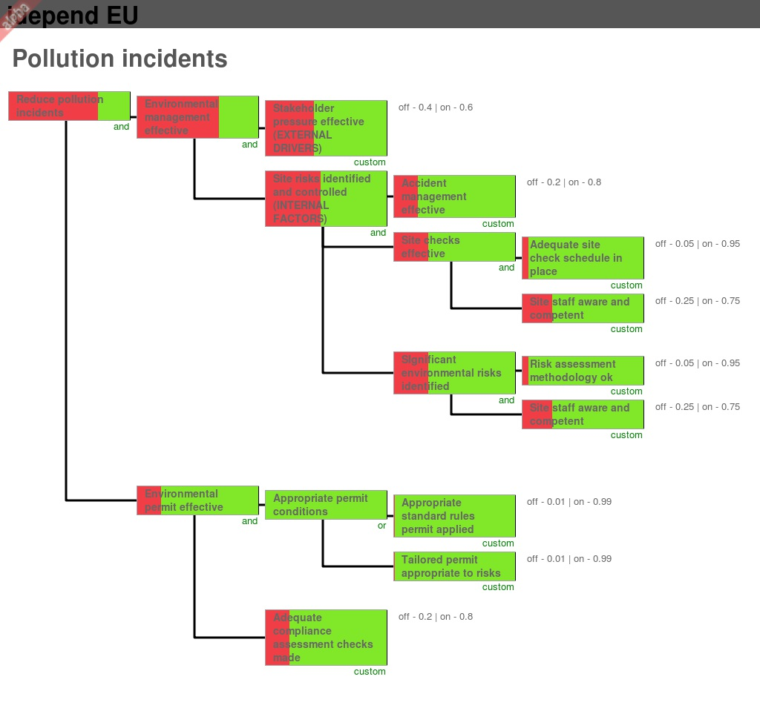

The probability of achieving the goal (to reduce pollution incidents) in this example without interventions was predicted to be about 25%.

## With Interventions

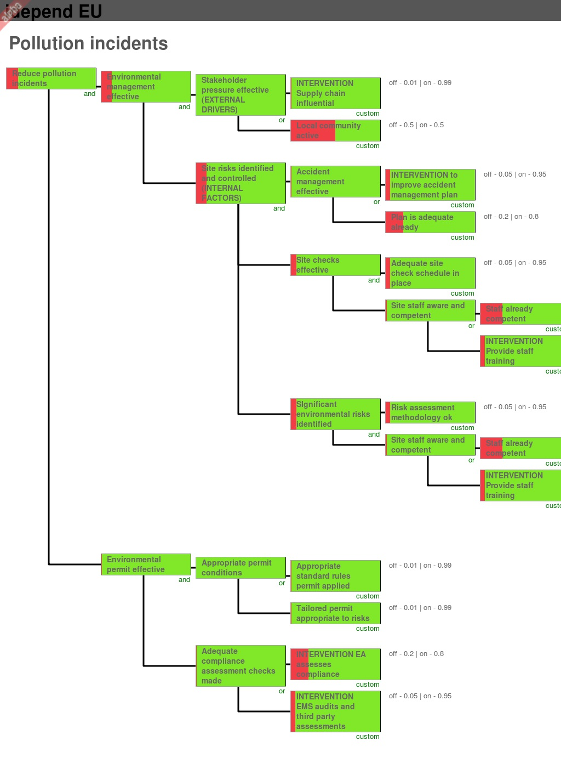

The probability of achieving the goal (to reduce pollution incidents) in this example with interventions added was predicted to be about 85%. END

1. This IMPEL project organised a webinar which was held on 26 June 2014 to demonstrate the *iDEPEND* Dependency Analysis tool. It can be downloaded from a link on this page: <https://connect.innovateuk.org/web/evidence/article-view/-/blogs/thank-you-for-joining-the-idepend-webinar-?p_p_auth=ndZz0P7A&_33_redirect=https%3A%2F%2Fconnect.innovateuk.org%2Fweb%2Fevidence%2Farticles%3Fp_p_id%3D101_INSTANCE_okNCIW6dT09i%26p_p_lifecycle%3D0%26p_p_state%3Dnormal%26p_p_mode%3Dview%26p_p_col_id%3Dcolumn-1%26p_p_col_count%3D1>
2. IMPEL 2012 Exploring the use and effectiveness of complementary approaches to inspection for ensuring compliance. <http://impel.eu/projects/exploring-the-use-and-effectiveness-of-complementary-approaches-to-inspection-for-ensuring-compliance/>
3. IMPEL 2013 Choosing appropriate interventions alongside inspections to ensure compliance and achieve environmental outcomes. <http://impel.eu/projects/choosing-appropriate-interventions-alongside-inspections-to-ensure-compliance-and-achieve-environmental-outcomes/>
4. The Regulatory Evidence Network can be found here: <https://connect.innovateuk.org/web/evidence>
5. Dependency Modelling – The Open Group 2012
6. Taylor CM, Pollard SJT, Angus AJ & Rocks SA. (2013) Better by design: rethinking interventions for better environmental regulation, *Science of the Total Environment*, 447 488-499. <http://www.sciencedirect.com/science/article/pii/S0048969712016300>.
7. IMPEL 2012 Exploring the use and effectiveness of complementary approaches to inspection for ensuring compliance. <http://impel.eu/projects/exploring-the-use-and-effectiveness-of-complementary-approaches-to-inspection-for-ensuring-compliance/>
8. SNIFFER (2013) Towards *a regulatory evidence portal*.  Topic area summary number 2: “Choose and Design Interventions”. <https://connect.innovateuk.org/documents/3153800/3815322/Evidence+Synthesis+-+Choose+%26+Design+Interventions.pdf/edd0c3d8-2b7c-4ef8-86e1-c4344ad69ac2>
9. Defra 2013. Draft instrument selection guide <http://randd.defra.gov.uk/Document.aspx?Document=11687_InstrumentSelectionGuidance041113-external.pdf>
10. Suitable Web Browsers are Mozilla Firefox, Google Chrome or Internet Explorer 10 or higher.
11. The web address is <http://idependeu.herokuapp.com/>
12. It is based on conventional Bayesian Belief Net methodology, but

    * This ***iDEPEND*** software now enables its deployment as a simple technique/ process – Dependency Modeling; and,
    * a simple, visual, drag and drop mind mapping tool.
    * It looks and feels intuitive and simple to use.
    * Changes in network logic, structure and input estimates are easily made (tear up and start again!) and
    * this is the last time we need to bother about the mathematics, the computer will take care of it for us!

   
13. Entity names must be 140 characters or less and names can be used more than once.
14. The documents mentioned and referenced in sections 1 and 2 are useful starting points for relevant evidence and each in turn refers to other evidence sources.
15. The Dutch Ministry of Justice (2004). The Table of Eleven a versatile tool. <http://www.sam.gov.lv/images/modules/items/PDF/item_618_NL_The_table_of_Eleven.pdf>
16. Entity names must be 140 characters or less and names can be used more than once.
17. Removing means that you keep the entity but just take it out of any particular model. It is not the same as deleting which is described in section 4.9
18. This project report has been drafted and will be available towards the end of 2014 via the project page on the IMPEL website here: <http://impel.eu/projects/choosing-appropriate-interventions-phase-3/>