hessenmarke 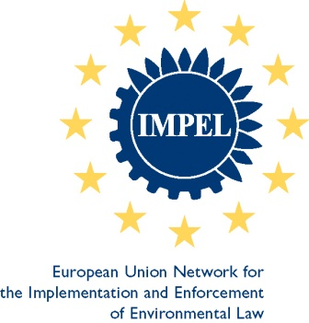

IMPEL Mini-conference

**Trend reversal in groundwater pollution**

**4 September 2023  
*Behördenzentrum Gutleut (Administrative centre), Frankfurt am Main***

***Draft agenda – v4, 21.7.2023***

09.00h Welcome by project manager and update on IMPEL project “Trend reversal in groundwater pollution” *(****Thomas Ormond****, Regierungspräsidium Darmstadt, DE)*

09.30h IMPEL and the implementation of environmental law (***Kristina Rabe***, *Federal Ministry of the Environment, DE*)

10.15h Reversing nitrate trends in groundwater since the 1980s – the Danish example  
*(****Birgitte Hansen****, Geological Survey of Denmark and Greenland (GEUS, DK)*

11.00-11.15h Coffee break

11.15h Trend reversal of nitrate pollution in Hessen from the perspective of water authorities *(****Astrid Bischoff****, Hessian Ministry of the Environment, DE)*

11.45h Trends in groundwater pollution and necessary measures from the perspective of a water supplier *(****Judith Grimm****, Hessenwasser, DE)*

Short discussion

12.30h-13.30h Lunch break

13.30h Practical experiences in cooperation with farmers *(****Matthias Peter****, Schnittstelle Boden, DE)*

14.10h The influence of soil texture on Nitrates leachability – 3 Romanian examples   
(***Iustina Popescu Boaja****, Geological Institute of Romania, RO)*

14.45h A brief history of reversing upward trends in groundwater nitrate pollution in England *(****Tim Besien****, Environment Agency, and* ***Susie Roy****, WSP/Wood, UK)*

15.25h Follow-up to “Trend reversal” with an IMPEL nitrate project *(****Annabill Rasp****, Regierungspräsidium Darmstadt, DE)*

15.30h Final discussion

16.00h End of conference