Questionnaire
Soil Washing
IMPEL Project no. 2020/09

Delivering time 5th October 2021 – 15th December 2021

TABLE OF CONTENTS

Context 3
Introduction 5
1. Your contact details 9
2. Site background 10
3. Pilot-scale application in field 14
4. Full-scale application 18
5. Results 22
6. Post treatment and/or Long Term Monitoring 23
7. Additional information 24
Glossary of Terms 28

Context

The contaminated sites management is a process that has different speeds in Members States. This is due partly on difference in legislation that would mean different definitions as for making some examples “potentially contaminated sites”, “contaminated sites”, “remediated sites”. For this reason, the European Commission-JRC launched an initiative with EEA-EIONET network to find common definitions and a survey in MS in 2018 (https://ec.europa.eu/jrc/en/publication/status-local-soil-contamination-europe-revision-indicator-progress-management-contaminated-sites) that resulted in defining 6 site statuses.

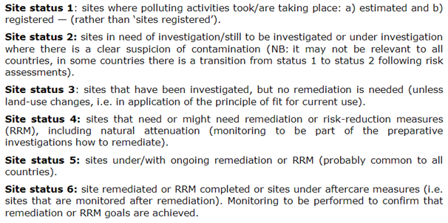

The last definition Site Status 6 refers to remediation that independently which are the targets (reaching a concentration limit set by law, reaching an acceptable risk for human health, reaching an acceptable environmental risk or other) is more or less common to all. The fact is that the progress in management go slowly in particular for the last phase with some of the countries with substantial no progress, the report says.
This project aim to speed up the process, focusing to the remediation phase that is often the bottleneck, with Remediation Verification Scheme.

The desired outcomes are:
• Support/exchange technical experience required to make progress with the task “Remediation verification scheme” in Europe in order to enable those MS in which no procedure is currently taking place to have one reference
• Schemes for remediation verification

Introduction

This questionnaire looks at the input of case studies where Soil Vapor Extraction were applied in a contaminated site. The questionnaire is divided in four steps:

1) The pilot study
2) The treatment
3) The enhancement applied
4) The post remediation scheme

The questionnaire will remain active in the period comprehended between 5th October to 15th December 2021 for the collection of case study. Late submission could be evaluated by the project team.

Each case study may have details of the site location, details of the author(s) and their affiliation and companies involved. Those information would help in understanding more about the site but are not mandatory.
At least one contact point is mandatory, for resolving any potential problem related to the publication.

It is allowed to make reference to registered products and/or patent but it is necessary to make reference to active species present and eventually by-products or side effects (e.g. pH increase).

The purpose of this project is to analyse a collection of case studies in order to identify criteria to effectively and promptly assess the correct evaluation of each step of the remediation activity. In particular, the criteria for evaluating and monitoring the performance of each step will be defined through the determination of some clues and evidences. Consequently, the intended outcome of the project is also to create a “Remediation Verification Scheme” that may be used as tools for practitioners. This tool could not necessarily be applied in all the situations but it will be an important reference to understand if the remediation technology is performing as planned.

Please note: data on the costs, on environmental net benefit as well as the sustainability aspects are not included in the objective of this study.

The purpose of this Questionnaire is to collect specific information on cases of remediation technology. To do so, you are kindly requested to submit one or more case studies each with a different file.
In case you cannot fill the questionnaire please answer to the last question in order address the project team your possible remarks, concerns, requests, suggestions.

As previously mentioned, the responses of the filled Questionnaires will be analysed in order to identify criteria for the evaluation of the performance of the remediation. The experiences collected may be useful to prepare the monitoring plan of different remediation phases for similar cases.

You can both fill the Questionnaire in Annex I and upload documents in English.

Please copy-paste, in the Questionnaire answers, any images, photos, maps, graphs, flowcharts and diagrams that can be useful for a better understanding.
Please send the Questionnaire to marco.falconi@impel.eu.
In case the file of the filled Questionnaire and/or of any useful document attached is too large, please send it/them to via We Transfer (https://wetransfer.com/) or Share File (https://www.sharefile.com/) or any other preferred internet tool.

Final note: The Questionnaire should not be completed only with successful cases of remediation technology application but also with unsuccessful assessment cases; in fact, for those unsuccessful cases, shortcomings and improvement actions will be identified and analysed.
Moreover, feel free to share this questionnaire to inspectors, a public officers or any other stakeholders. Participation or consultancy, site owners, environmental service companies are welcomed.

Thank you very much for your collaboration from all the WLR project team.

If you need assistance or clarifications, you may contact:
Mr. Marco Falconi
Email: marco.falconi@impel.eu
Mobile Phone: +39 3471204170

DISCLAIMER:
The questionnaire is subject to the Directive 2003/4/EC of the European Parliament and of the Council of 28 January 2003 on public access to environmental information.
As a consequence, the information contained in the filled Questionnaire will not be confidential, not only for the information of the intended recipient and may be used, published or redistributed by IMPEL without the prior written consent of the compiler.

Annex 1
Soil Washing
IMPEL Project no. 2020/09

Delivering time 5th October 2021 – 15th December 2021

- Your contact details

  - Name and Surname*
  - Country/Jurisdiction
  - Organisation
  - Position
  - Duties
  - Email address
  - Phone number
* If you do need, you can fill the Questionnaire as anonymous. In this case, we kindly ask you to fill just the box no. 1.6, 1.7, that will be used to contact you for any problems related to the publication.

- Site background
2.1 History of the site
Please describe the history of the site (you may add one or more pictures)
- (your answer) …

- EXAMPLE OF ANSWER

Basket Creek was used in the 1960s for illegal disposal of liquid refinery and other hazardous wastes. In 1991, soil at the site was identified as a RCRA hazardous waste exhibiting the Toxicity Characteristic (TC) for lead, MEK, and TCE.

2.2 Geological setting
Please describe the geological setting (you may add one or more pictures)
- (your answer) …

- EXAMPLE OF ANSWER

Site soil consists largely of fine sands with some silts, interbedded with veneer-thin stringers of sand and thicker layers of nearly saturated silts and clays. The depth to ground water is approximately 10 meters below ground surface.

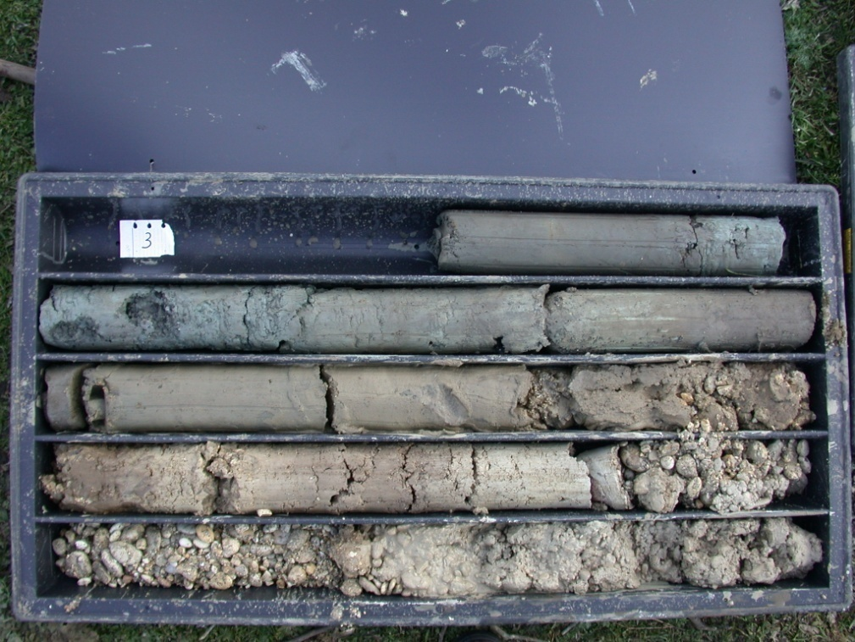

2.3 Contaminants of concern
Please describe the contaminants of concern
- (your answer) …

- EXAMPLE OF ANSWER

Organic Compounds (Volatiles - Halogenated: trichloroethene (TCE); and Volatiles - Nonhalogenated: toluene, methyl isobutyl ketone (MIBK), and methyl ethyl ketone (MEK)) and Inorganic Compounds, (Heavy Metals: lead and mercury)
- Toluene: BDL-220,000 mg/kg
- MIBK: BDL-66,000 mg/kg
- MEK: BDL-23,000 mg/kg

2.4 Regulatory framework
Please describe the regulatory framework applicable
- (your answer) …

- EXAMPLE OF ANSWER

EPA signed an Action Memorandum for Basket Creek. Initial activities included sampling to characterize the nature and extent of contamination at the site. Tue soil was found to be a RCRA hazardous waste by exhibiting the Toxicity Characteristic (TC) for lead, methyl ethyl ketone, and ·trichloroethene.
Additionally, the soil was found to be a California List Waste under the RCRA Land Disposal Restrictions program because total halogenated organic compounds were greater than 1,000 parts per million (ppm) and, therefore, waste from the site was prohibited from land disposal. As described under the Contamination Characterization section of this report, elevated levels of mercury were also found in the soil; however, the soil was not identified as exhibiting the TC for mercury.
The action memorandum identified treatment targets for soil, including TC regulatory levels for selected volatile organic compounds (VOCs) and metals, and the California List regulatory level of 1,000 ppm for total HOCs.

- Pilot-scale application in field
3.1 Soil washing system
Please describe the number and characteristic of soil washing system in the pilot scale application in field
- General layout
- Washing Solutions
- Other info

- (your answer) …

- EXAMPLE OF ANSWER

The washing solution was made up biosurfactants that were mixed with water with a ratio 1 kg:1 ton. The general layout of the pilot study is represented in the following picture

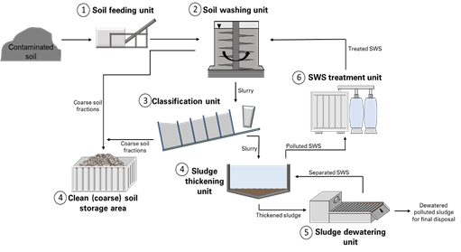

3.2 Feasibility study
Please describe the number and characteristic of parameters used for evaluating Soil Washing as a feasible alternative
- Mass removal
- Extraction rates
- Low clay percentage
- Low organic carbon
- (your answer) …

- EXAMPLE OF ANSWER

After exhaustive soil sampling and subsequent particle-size separation via wet sieving, chemical and mineralogical analysis revealed that the finer fractions held very high concentrations of As (up to 32,500 ppm) and Hg (up to 1600 ppm). These elements were both associated mainly with Fe/Mn oxides and hydroxides. Textural and geochemical data were correlated with the geological substrate by means of a multivariate statistical analysis. In addition, the Hg liberation size (below 200 μm) was determined to be main factor conditioning the selection of suitable soil washing strategies. These studies were finally complemented with a specific-gravity study performed with a C800 Mozley separator together with a grindability test, both novel approaches in soil washing feasibility studies. The results highlighted the difficulties in treating "La Soterraña" soils. These difficulties are attributed to the presence of contaminants embedded in the soil and spoil heap aggregates, caused by the meteorization of gangue and ore minerals. As a result of these two characteristics, high concentrations of the contaminants accumulate in all grain-size fractions. Therefore, the soil washing approach proposed here includes the grinding of particles above 125 μm.

3.3 Water Treatment
Please describe if and which water treatment was installed in the pilot scale application in field
- Granulated Activated Carbon
- Stored and disposed off site
- Sent to a Wastewater Treatment Plant
- Dumped in sewerage
- Nothing
- (your answer) …

- EXAMPLE OF ANSWER
The effluent goes to an existing wastewater treatment plant.
This waste sludge or water gets treated in a Waste Water Treatment Plant & sludge dewatering. The WWTP is fully automatic in operation by using Thickeners & Filter Press.

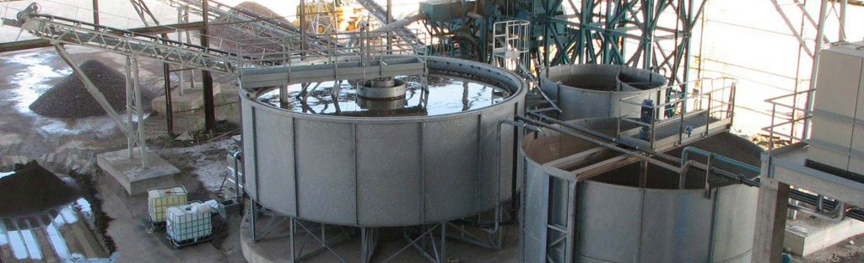

3.4 Control parameters
Please make a list of control parameters for the pilot scale application in field that are helpful for the feasibility full scale.
Field monitoring and sampling program that will adequately monitor the effectiveness of the treatment in three dimensions.
- (your answer) …

- EXAMPLE OF ANSWER
To assess the removal efficiency, the contaminants of concern are measured at the output of any washing cycle.

- Full-scale application

4.1 Soil washing system
Please describe the number and characteristic of soil washing system in the full scale application
- General layout
- Washing Solutions
- Other info

- (your answer) …

- EXAMPLE OF ANSWER

The washing solution was made up biosurfactants that were mixed with water with a ratio 1 kg:1 ton. The general layout of the pilot study is represented in the following picture

4.2 Feasibility study
Please describe the number of cycles needed to achieve the remediation target and any enhancement needed.

- (your answer) …

- EXAMPLE OF ANSWER

The contaminants of concern were heavy metals and TPH, so different washing solution were put in place with surfactants and pH modifiers. For heavy metals more cycvles were needed for lots 1,7,9 as there was an high concentration of zinc.

4.3 Water Treatment
Please describe if and which water treatment was installed in the full scale application in field
- Granulated Activated Carbon
- Stored and disposed off site
- Sent to a Wastewater Treatment Plant
- Dumped in sewerage
- Nothing
- (your answer) …

- EXAMPLE OF ANSWER
The effluent goes to an existing wastewater treatment plant.
This waste sludge or water gets treated in a Waste Water Treatment Plant & sludge dewatering. The WWTP is fully automatic in operation by using Thickeners & Filter Press.

4.4 Control parameters
Please make a list of control parameters for the full scale application in field that are helpful for the feasibility full scale.
Field monitoring and sampling program that will adequately monitor the effectiveness of the treatment in three dimensions.
- (your answer) …

- EXAMPLE OF ANSWER
To assess the removal efficiency, the contaminants of concern are measured at the output of any washing cycle.

- Results
5.1 Removal rate
Please briefly describe the efficiency of the treatment

- (your answer) …

- EXAMPLE OF ANSWER

Although EDTA solution is considered an efficient soil washing liquid for extraction of heavy metals from soils, its low biodegradability may alter soil properties and suppress plant growth. Alternatively, chlorides are safer and cheaper washing liquids than EDTA. To investigate the efficiency of chlorides versus EDTA in extracting heavy metals from contaminated soils, soil samples (pH 6.14±0.11) were collected from a local agriculture soil in Australia, artificially contaminated with either Pb, Cd or Cr at three different levels of 200, 400 and 600 mg kg-1, and then packed in capped plastic flasks. Batch washing techniques were followed with either EDTA or FeCl3 solutions (prepared at 4 different concentrations of 0.05, 0.1, 0.25 and 0.5 M), and soil suspensions were agitated for different time periods (from 5.0 min. to 60.0 min); afterward, the extraction efficiencies of the investigated metals were considered. The removal efficiency of Pb from the contaminated soil (200 mg Pb kg-1) after 5 minutes of EDTA application seemed to be relatively high (≈75%). Afterward this efficiency decreased gradually with time. The efficiencies of the extracted Cd and Cr by soil washing with EDTA increased significantly with increases in the agitating period. Generally, the extraction efficiencies by EDTA decreased noticeably with increasing levels of soil contamination. On the other hand, the efficiencies of Pb, Cd and Cr extractions were high – especially when increasing both the concentrations of applied FeCl3 solution and the time of agitation. The results also highlighted that soil washing with FeCl3 seemed to be more favourable over EDTA for rapid extraction of heavy metals from contaminated soils. The efficiencies of extracting heavy metals by soil washing with 0.5M FeCl3 for only one hour were 93.79±2.35%, 97.4±2.45% and 81.75±7.86% for Pb, Cd and Cr, respectively

- Post treatment and/or Long Term Monitoring
6.1 Post treatment and/or Long Term Monitoring
Please describe the monitoring parameters for post treatment and long term monitoring
- (your answer) …

- EXAMPLE OF ANSWER

There were test on the release at long term that resulted in materials that does not leach significant amount of contaminants.

- Additional information
7.1 Lesson learnt
Please describe Key findings and lessons learned about this site.
Difficulties and weaknesses, successes and strengths, keystones, shortcomings and rooms for improvement. Please give your opinions as regard to 1) methodology and procedures, 2) technical aspects 3) legislative, organizational aspects.
- (your answer) …

7.2 Additional information
Given the clues and the evidence found in the specific case, can you suggest criteria for the determination of clues and evidence referable to the success of remediation?
- (your answer) …

7.3 Training need
Please give your opinion as regard to the training needs from the technical, procedural, organizational point of view and which training tool you think is effective (workshops, training on-the job, webinars, e-learning, etc.).
- (your answer) …

7.4 Additional remarks
Please feel free to give any additional information, remarks, concerns, requests, suggestions
- (your answer) …

Glossary of Terms

A glossary will help a you to maintain the level of precision necessary for key terms and maintain consistency across the text. We found out that sometimes terms that sounds similar like “contaminated” and “polluted” are used in the same way as synonyms in some country, while in other they have different meanings (due to legislation or for other reasons). So fill in this glossary for your key elements and of course for acronyms.

Term (alphabetical order) | Definition
VOC | Volatile organic compounds (VOCs) are organic chemicals that have a high vapor pressure at ordinary room temperature
.... | .....

